

Social Benefit Review 2025 / 2026
Social value in procurement is all about making a positive difference through the way we buy goods and services. It’s not just about getting the best deal, it’s about making sure that every contract helps support jobs, protect the environment, and gives back to the community. Social value is built into the contracting process with Working4U taking the lead in negotiating and securing the benefits.

The Social Value Working4U officer has been working with 92 contractors (across 115 contracts in total) during 25/26 to deliver a wide range of social benefits and the delivery has continued to grow, with donations totalling £100,055 25/26. This has been through cash donations and donations of materials such as, food items, clothing, landscaping materials, etc. Contractors have also donated 1169.5 hours of their time and labour to projects in our community via school inputs, job fairs, site visits and mock interviews sessions. The following report showcases the work of social benefits, and the full breakdown can be found in appendix 1.

Working4U Employability

During 2025/26, Working4U delivered a significant programme of employer engagement activity across West Dunbartonshire, with strong contributions from the construction and engineering sectors. Employers provided substantial financial and in-kind support, including funding for accredited training, CSCS vouchers, employability courses, Thrive activities, and school uniform support. This enabled the delivery of a wide range of interventions, including work experience placements, foundation and modern apprenticeship pathways, construction academies, site visits, careers inputs, mock interviews, and employer-led training programmes. Engagement from key employers such as McTaggart Construction, Balfour Beatty, City Technical, CCG, Network Rail, and Clark Contracts has resulted in multiple positive outcomes, including permanent employment, apprenticeships, traineeships, and sustained progression routes. This activity demonstrates strong employer commitment to social value, skills development, and improving employment outcomes for residents through Working4U.

Total Donations Working4U Received 25/26
Cash Donations | £26,681
Value of Materials | £4,920
Labour / courses, inputs, etc. | 201 hours
Cost in Kind | £2,703.45
Work experience weeks | 34
Employment opportunities | 7

Education

Our contractors have been very keen to engage with people of all ages and backgrounds to deliver inputs which support Education’s aims and goals.

Extensive employer engagement activity was delivered across the Education and West College Scotland sectors, supporting pupils from primary through to college level. Employers contributed significant time, resources, and funding to deliver workshops, careers events, mock interviews, work experience placements, site visits, STEM activities, and trade-specific taster sessions. This included construction, engineering, sustainability, digital and AI-focused inputs, alongside practical activities such as Lego challenges, design tasks, mock interviews, and hands-on experience in trades including joinery, plumbing, plastering, electrical work, and quantity surveying. Activity was delivered in partnership with a wide range of employers, including Balfour Beatty, Network Rail/Story, City Building, Clark Contracts, CCG, Page/Park, City Technical and others, reaching large numbers of pupils across primary, secondary and college settings. Employers also provided financial and in-kind support, including funded transport, equipment donations, materials for schools, and contributions to school resources. This sustained engagement has strengthened career pathways awareness, supported skills development, and enhanced progression opportunities for young people across West Dunbartonshire.

Total Donations WDC Education Received 25/26
Cash donations | £202
Donations of materials (value) | £810
Work experience weeks | 3
Donations of labour (hours) | 450.5
Cost in kind (labour) | £7237

Food Insecurity
Foodbanks are a crucial part of the support system for vulnerable individuals and families, providing emergency food relief, promoting social cohesion, reducing food waste, and helping to raise awareness about issues of poverty and hunger and many of the contractors donate to these causes.
A total of £6,800 in financial and in-kind support was secured across West Dunbartonshire. Beneficiaries included Lomond Food Pantry, Old Kilpatrick Food Parcels, Golden Friendships, Duntocher Village Hall, and Food for Thought Foodbank. This support has contributed directly to addressing food insecurity, strengthening warm hub provision, and improving the capacity of community organisations to deliver essential services, including food distribution and social support for vulnerable residents. The collective contribution reflects strong employer and partner commitment to supporting local communities and tackling cost-of-living pressures.
Total Donations Received 25/26
Cash donations | £6800
Food and sundries donations | £600

Green Spaces and Environment

Community gardens provide a welcoming and positive place for WDC residents to engage, and social benefits has continued to support this work through donations of cash and materials. A wide range of community groups and voluntary organisations across West Dunbartonshire benefited from significant employer-led financial, in-kind and volunteering support. This included practical infrastructure improvements such as the donation and transportation of reclaimed kerb stones to Dullichip Community Garden, CCTV and alarm installation funding for Bellsmyre Community Garden, and major building repairs delivered free of charge at Knowes Sports Centre.
Employers also provided hands-on volunteer support, with staff time dedicated to refurbishing gardens at Dumbarton District Women’s Aid, litter-picking and environmental improvements in Balloch Park, and internal painting works at Improving Lives premises. Financial contributions supported community resilience and wellbeing, including donations to Tullochan Trust, Bonhill Community Garden, Flourishing Faifley, The Leven Litter Pickers, and local youth organisations such as the 1st Vale of Leven Boys Brigade & Girls. Additional in-kind support included provision of vehicles for major clean-up events, installation of fire doors at Dalmuir Barclay Church, and building repairs at Dynamite Gymnastics. Collectively, this support enhanced community facilities, strengthened green spaces, and improved the capacity of local organisations to deliver services to residents.

Total Donations Received 25/26
Cash Donations | £6,300
Donations of materials (value) | £ 34,595.57
Donations of labour (hours) | 414
Cost in kind (labour) | £5,568.30

Sports, Wellbeing and Art
Employer partners provided a broad range of financial and in-kind contributions to support sports, wellbeing and community organisations across West Dunbartonshire. This included donations of specialist equipment such as large training tyres for Clydebank Community Sports Hub, sports kits and materials for Renton Craigandro Football Club, and outdoor and play equipment for Time for Tully.
Financial contributions supported grassroots sport and inclusion, including donations to Street League, West Dunbartonshire Swimming Club, Antonine Boxing Club, Clydebank FC Under-14s, and Knowetop. Creative and youth-focused organisations such as Faifley Art Club and Clifftop Projects also benefited through funding and donated resources, including stationery and materials.
Collectively, these contributions have strengthened access to sport, physical activity, creativity and positive youth engagement, helping local organisations to enhance provision, increase participation, and support wellbeing across communities.
Total Donations Received 25/26
Cash Donations | £3,970
Donations of materials (value) | £1,350.81

Appendix 1
For a full breakdown of Social benefits delivered in the 2025/2026 period please click on the file below.
X




Exxon Infrastructure Development Project
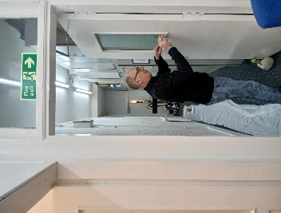
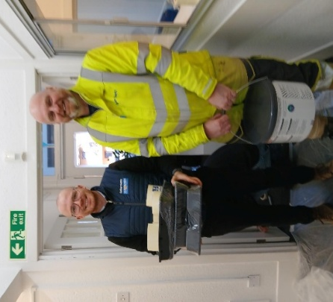
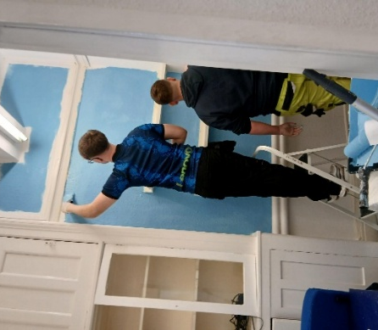
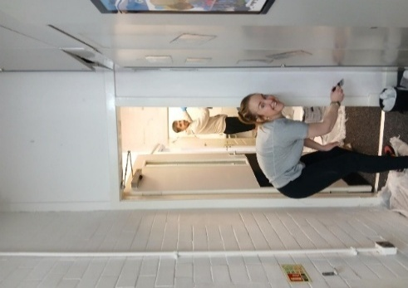
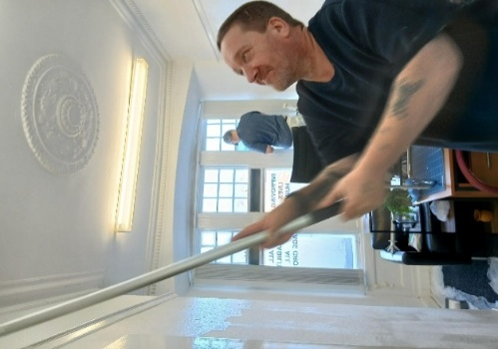
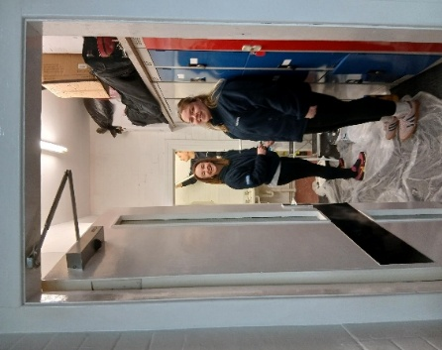
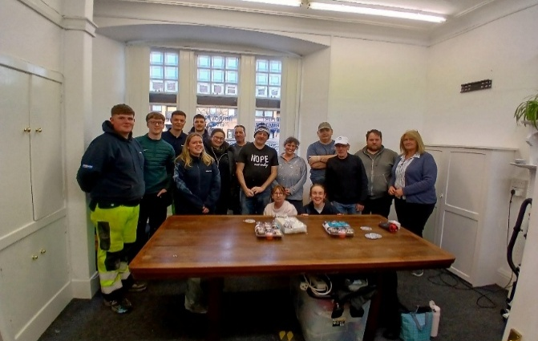
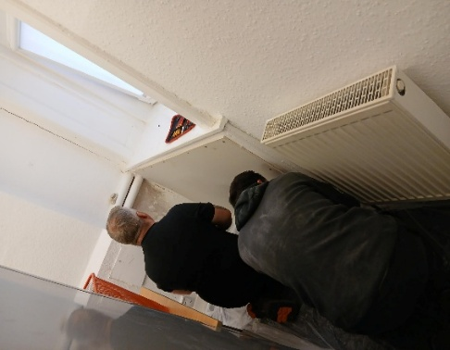
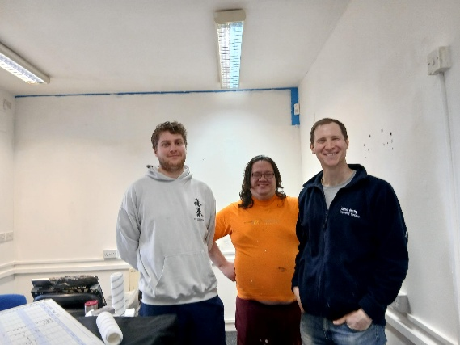
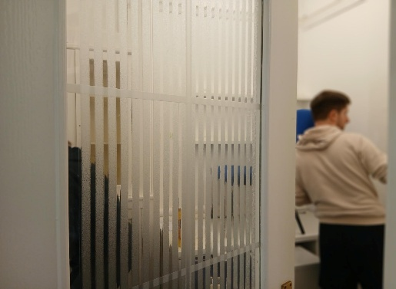
This activity was made possible through the dedication and enthusiasm of the Balfour Beatty team, alongside materials provided by the Exxon redevelopment site.

This work reflects the positive impact that social benefits can deliver in West Dunbartonshire and demonstrates social impact at its best, improving spaces, strengthening community partnerships and supporting those who need it most.

As part of Balfour Beatty’s commitment to delivering meaningful social value, the Project Team were proud to support Improving Lives, a Clydebank-based charity providing vital support for people with disabilities, their families and carers across West Dunbartonshire
Across two days, a total of 20 volunteers from the Exxon redevelopment site in Dumbarton and Balfour Beatty’s Head Office at Maxim Park joined forces with charity volunteers to deliver a full internal refresh of the organisation’s community hub.
Working collaboratively, volunteers repainted the entire premises, creating brighter, calmer and more welcoming spaces for those who rely on the charity’s services.



“Arnold Clark has recently generously donated £2,000 to support two fantastic local charities in Clydebank – The Clydebank Men’s Shed and Golden Friendships. This contribution will help both organisations continue their invaluable work in the community, providing social opportunities, support, and a welcoming space for people to connect and thrive. A huge thank you to Arnold Clark for making a real difference locally!”
Clair McCarron, Arnold Clark: At Arnold Clark we believe that by giving back to our communities today, we can help build a better future for generations to come. We try to support as many charities and community groups like Men’s Shed and the Golden Friendship Group as we can in order to care for and strengthen the local areas where we live and work.”
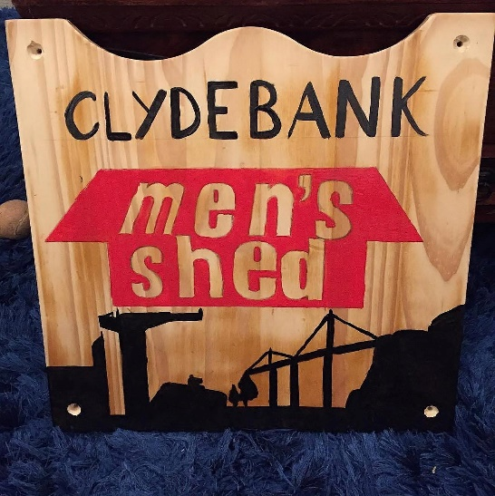

Jim McLaren, Golden Friendships: “Thank you so much for your donation. We are now able to buy an industrial fridge to store our food as we were using a commercial one. We have served 750 free Christmas dinners in our efforts to tackle loneliness in the community, and we are currently serving up to 100 free dinners every Tuesday night from the start of October until the end of March through our project called Heating and Eating, to help anyone struggling with the current cost-of-living crisis.”

Chris Laws, Clydebank Men’s Shed: “The very generous donation of £1000 from Arnold Clack, has enabled us to replace two old and decrepit machine tools that are vital to us here at Clydebank Men’s Shed. We use these machines on a daily basis on projects for our local community. This is a vital source of revenue, which helps to keep us afloat financially.”


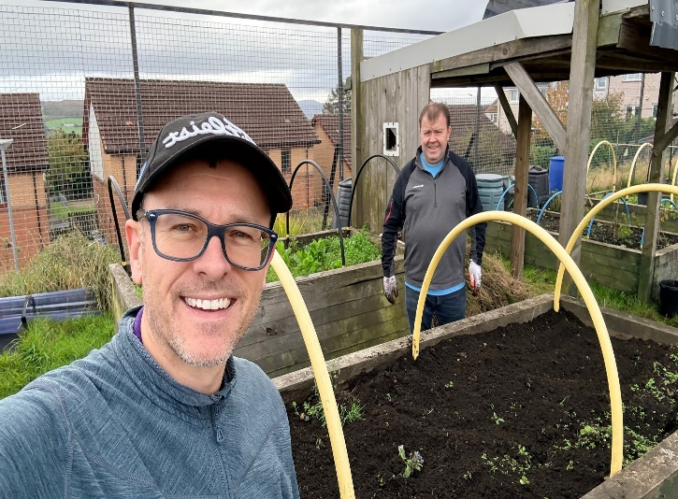
BT Volunteer days with Bonhill Community Garden

Two senior BT staff members volunteered for two days with Bonhill Community Garden on the 8th and 9th of October 2025. They spent the time clearing areas of the garden, cutting grass, pruning, and weeding.
John Goy - Private Networks & IoT Solutions Consultant said “BT thoroughly enjoyed a recent volunteer working party experience with Bonhill Community Garden, a brilliant project where the local community has taken over an uncared-for part of their estate and turned it into an oasis of nature and community”
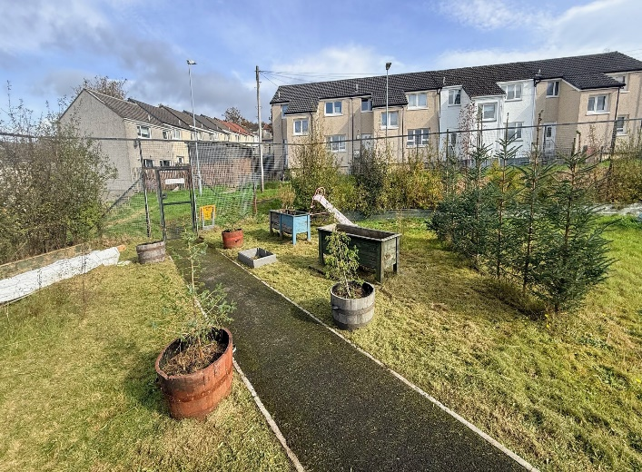
Brian Jackson – Director of BT Surveillance & Smart Solution said “Although the gardening, grass cutting and tree pruning was hard work, the effort was certainly worth it and to stand back at the end of 2 days and see the positive visual impact was very satisfying. I can say that the two of us that worked with the team certainly got a positive boost to our mental health. This was a brilliant experience”
Catherine Howard Secretary Bonhill Community Garden
“We have constant weeding, grass cutting, and shelter belt hedging to tend to, and both John and Brian jumped straight in. The difference they made is fantastic. Many of our volunteers feel comfortable taking on tasks they’re able to manage, which often leaves the more strenuous and tiresome jobs to those more able, like John and Brian. The work they carried out made a real difference to the morale of the group. Volunteers can now freely manage these areas, and we aim to repurpose the raised beds to form a new strawberry patch. Their input was incredibly valuable and beneficial to both us volunteers and our growing space.



The Willox Park Development

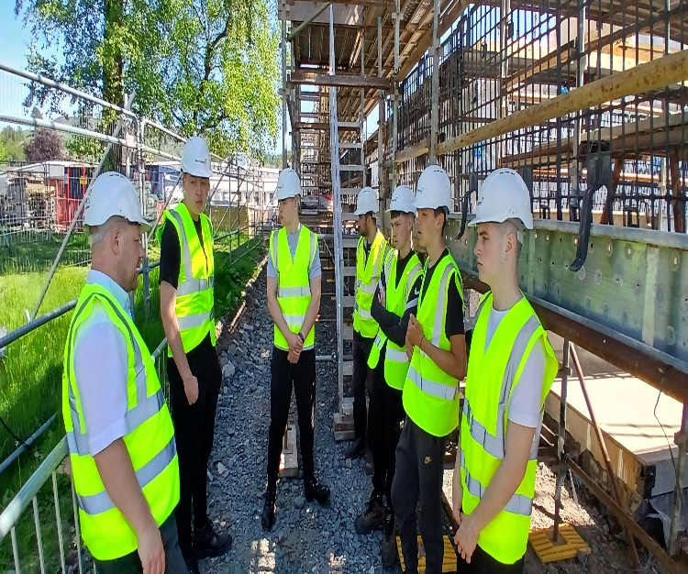

Pupils in their Senior Phase years at school, from S4 to S6, can choose a Foundation Apprenticeship as one of their school subjects. During the apprenticeship, learners work on employability skills, gain an understanding of the industry and the job roles within the sector, and collaborate on a project to meet a brief from a real client. They also develop practical skills in painting and decorating, bricklaying, and joinery. McTaggart Construction was very keen to support the Foundation Apprenticeships and provided six pupils with a five-week programme consisting of a series of planned interventions.

Ross Hammel, McTaggart Construction: McTaggart is committed to supporting the next generation of the construction workforce. The Willox Park development has been used to enhance industry learning and support the WDC Foundation Apprenticeship programme.
These site-based learning opportunities not only promote the construction industry but also provide a unique and valuable environment for young people interested in the built environment.

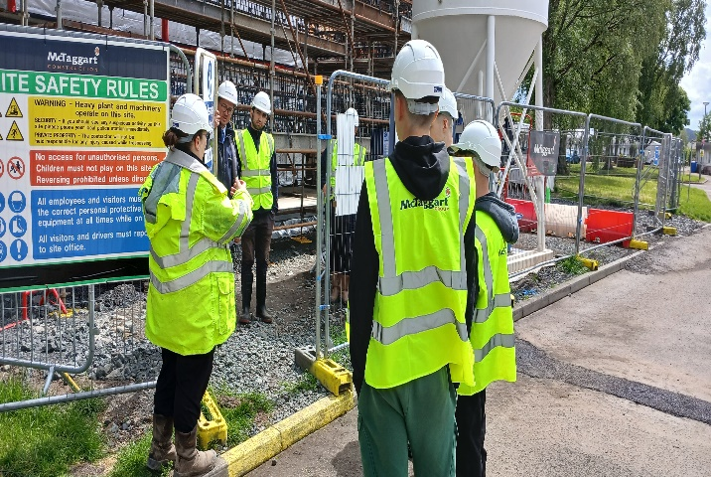
Stephen Knox, Working4U: Ross and the team at McTaggart's provided work placements for our Civil Engineering Foundation Apprentices. The experience included a combination of professional talks, hands-on activities, and site observations. Topics covered various aspects of the construction industry, such as health and safety, engineering, quantity surveying, and sustainability, among others. The placement not only supported the young people in completing their qualifications but also gave them valuable insight into the industry as a whole. Participants found it both interesting and informative to learn about the different career opportunities within the construction sector, and they enjoyed observing the work being carried out on-site. This experience was essential for the apprentices to complete their course and helped them become more knowledgeable about the construction industry overall.

