

West Dunbartonshire

Empty Homes Strategy

(Private Sector) 2024/29

Contents

1. Introduction 2

1.1 What is meant by Empty Homes? 3

2. The Legislative and Policy Context for Empty Homes 4

2.1 Statutory Requirements 4

2.2 The National Policy Context for Empty Homes 4

2.3 The Local Policy Context for Empty Homes 7

3. Evidencing the Need to Tackle Empty Homes in West Dunbartonshire 11

3.1 Profiling Empty Homes 11

3.2 Long Term Empty Homes 11

3.3 Housing Need and Demand 14

3.4 Homelessness 14

3.5 Temporary Accommodation 15

3.6 Private Rented Sector 16

4. Local Action, Challenges & Barriers in Tackling Empty Homes 17

4.1 Empty Homes Projects and Initiatives in West Dunbartonshire 17

4.2 Challenges and Barriers to Tackling Empty Homes 21

5. The Strategy for Tackling Empty Homes in West Dunbartonshire 23

6. Empty Homes Action Plan 24

7. Monitoring Progress and Evaluating 26

7.1 Evaluation 26

8. Consultation & Engagement 26

# 1. Introduction

West Dunbartonshire Council is pleased to present this Strategic Empty Homes Strategy covering the period 2024 – 2029.

This Empty Homes Strategy seeks to:

* Set a target of returning 125 empty homes back into use in West Dunbartonshire over the period of this strategy.
* Support homeowners to bring empty homes back into use, increasing local housing options and meeting housing need.
* Enable housing regeneration, placemaking and neighbourhood improvement activity which improves community safety, environmental quality, and housing condition.
* Make a positive contribution to the building reuse and repurposing agenda aligned to the Council’s wider ambitions for tackling climate change.

The Empty Homes Strategy’s main purpose is to provide a clear picture of how we aim to return empty private homes back into use. By tackling empty homes this will contribute to meeting housing needs over the Authority, assist in the regeneration of our communities, support our local economy and climate change.

The Scottish Government’s Housing to 2040 has an ambitious vision of what housing should look like over the next two decades and a plan of how they see this should be achieved. By bringing empty homes back into use this will help deliver on the priorities:

* More homes at the heart of great places
* Affordability and Choice
* Affordable warmth and zero emissions homes
* Improving the quality of homes

The Empty Homes Strategy aligns with the Local Housing Strategy 2022-2027, theme of Place and Community.

The previous Empty Homes Strategy 2021-2024 aimed to return 75 empty homes back into use. During the period of the strategy, we have reported to the Scottish Empty Homes Partnership that 83 properties of varying type, size and location have been brought back into use to provide the communities of West Dunbartonshire with more available housing.

Since the previous Strategy we have: -

* Moved from having a part-time Empty Homes Officer to a full-time Officer, from July 2022.
* And further developed working relationships with colleagues in Building Standards, Environmental Health, Planning, Regeneration and Social Work (Criminal Justice).

## 1.1 What is meant by Empty Homes?

In this Empty Homes Strategy, empty homes have been classified using the following definitions:

* **Long term empty properties**. These are dwellings that have been empty for 6 months or more and are liable for council tax. The most recent figures published by the Scottish Government show that there were 494 long term empty properties in West Dunbartonshire in September 2023.
* **Unoccupied exemptions**. These are properties which are empty and exempt from paying council tax. The most recent figures published by the Scottish Government show that there were 848 unoccupied exemptions in West Dunbartonshire in September 2023. There is no requirement for a property to have been empty for more than 6 months before it can be included in this category.
* **Second homes**. Homes which are furnished and lived in for at least 25 days in a 12 month period but not as someone’s main residence. The most recent figures published by the Scottish Government show that there were 19 second homes in West Dunbartonshire in September 2023.

Understanding why homes become empty can play a significant role in bringing the properties back into use, some reasons for homes becoming empty can include:

* Inheritance and ownership difficulties
* They do not want to become a private landlord
* Repossessions
* Major repairs and lack of resources
* Difficulty engaging or location of owners

For owners, empty homes can have considerable financial impacts in terms of lost rental income, mortgage payments, council tax, insurance, maintenance and security. Empty Homes can therefore pose the potential for significant financial loss.

From a wider community perspective, empty homes can cause a negative appearance in terms of place, undermine regeneration efforts, prevent common works from taking place and lower the value of nearby properties. Furthermore, properties which are inactive within the housing market do not contribute to economic activity within communities and do not help with homelessness prevention or meeting housing need.

This Empty Homes Strategy focuses on long term empty properties, setting out the approaches that the Council and partners will take to bring homes back into use. Having said this, it should be noted that unoccupied exemptions may include properties where the previous owner has died and/or properties that have been repossessed. The Empty Homes Strategy also sets out approaches for bringing these properties back to use.

This Empty Homes Strategy can therefore deliver significant economic and financial benefits to West Dunbartonshire communities, local businesses, owners, landlords and residents by contributing to:

* enhancing housing supply to meet housing need
* reducing homelessness by increasing housing options
* achieving Net Zero Targets and carbon savings through the retrofitting of existing properties as an alternative to new supply
* reducing neighbourhood complaints and the avoidable deployment of public resources
* reducing requirements for Police and Fire Services to attend empty homes
* financial returns for owners by realising asset value or generating rental income
* improving aesthetic appearance and sense of place within a community
* progressing common works to improve housing standards across other homes.

# 2. The Legislative and Policy Context for Empty Homes

There is a rich and diverse policy context for tackling empty homes in Scotland, which supports the delivery of empty homes activity and influences the contribution that empty homes can make to national, local and community objectives.

It is important that this Empty Homes Strategy supports and helps deliver national housing outcomes and targets, whilst also reflecting the local needs and priorities set out by community planning and housing partnerships.

This Empty Homes Strategy is set within the wider Community Planning and Local Housing Strategy for the Council and its partners. The Strategy defines the contribution that empty homes can make to local strategic priorities and meeting the targets set out in Scotland’s first national Housing Strategy: ‘Housing to 2040’. The national and local strategic framework that supports and enables the delivery of the Empty Homes Strategy is set out in more detail below.

## 2.1 Statutory Requirements

There are a number of statutory requirements placed on West Dunbartonshire Council and those that relate directly or indirectly to bringing empty homes back into use, are as follows:

* Local Government Finance (Unoccupied properties etc.) (Scotland) Act 2012. This allows local authorities to charge increased Council Tax on certain homes that have been empty over a year
* The Housing (Scotland) Act 2011 which places a duty on local authorities to develop a Local Housing Strategy (LHS) which set out the local authority’s and local partners’ vision for the supply of housing across all tenures and types of housing provision
* Local authorities’ duties to homeless people including a statutory responsibility to anyone threatened with, or experiencing, homelessness
* House Condition (Housing (Scotland) Act 2006, Section 10) creates duties to have in place a Below Tolerable Standard Strategy, Housing Renewal Area Policy and Scheme of Assistance Strategy
* Tackling the effects of Climate Change – Section 44 of the Climate Change (Scotland) Act 2009
* Fuel Poverty (Targets, Definition and Strategy) (Scotland) Act 2019 introduces a new statutory target for reducing fuel poverty. The target is that by 2040, as far as reasonably possible, no household, in any Local Authority area, in Scotland is in fuel poverty; and, in any event, no more than 5% of households, in any local authority area in Scotland are in fuel poverty. No more than 1% of households in Scotland should be in extreme fuel poverty.

This legislative framework not only places powers and duties on West Dunbartonshire Council but offers mechanisms which can drive empty homes activity and intervention including enforcement action, advice, assistance and investment.

## 2.2 The National Policy Context for Empty Homes

The national policy context places the empty homes agenda within a framework of strategic ambitions around housing, place, community, net zero and the Scottish economy. Whilst there are currently no statutory requirements for local authorities regarding empty homes, the Scottish Government is keen to encourage empty homeowners to bring properties back into use and in particular, to increase affordable housing supply in Scotland to tackle shortages in this sector.

There are currently eleven National Outcomes describing what the Scottish Government wants to achieve. By proactively tackling empty homes and bringing them back into use, the Council and partners can contribute to delivery of several of these as shown below.

|  |  |
| --- | --- |
| National Outcome | Empty Homes Contribution |
| **Economy:** We have a globally competitive, entrepreneurial, inclusive and sustainable economy | Assisting and enabling empty homeowners to bring their properties back into use, provides greater housing choice, improves the aesthetic appearance of communities and can contribute to making communities more robust and resilient through investment, job creation and greater local spend |
| **Fair work and business:** We have thriving and innovative businesses, with quality jobs and fair work for everyone | Empty homes can contribute to fair work and local business agendas through job creation, spend on materials and resources, learning and development of a skilled workforce and increasing the number of households accessing services, amenities |
| **Communities:** We live in communities that are inclusive, empowered, resilient and safe | Tackling empty homes improves community safety, encouraging greater levels of resident occupation to reduce security risks and enhance neighbourhood quality |
| **Poverty:** We tackle poverty by sharing opportunities, wealth and power more equally | Empty homes that are brought back into use can contribute to increasing the supply of affordable housing and therefore assist in tackling the poverty agenda. |
| **Environment:** We value, enjoy, protect and enhance our environment | Refurbishment and retrofitting have significantly less impact on the environment and carbon emissions than newbuild housing activity. Empty homes can contribute to increasing housing choice and supply whilst reducing impact on consumption and production.  Bringing empty homes back into use safeguards properties at risk by allowing works to be carried out not only for that property but others where there are communal repairs. Ensuring properties are protected and lived in increases housing supply and provides a better environment for those who wish to live in communities in the future |
| **Health:** We are healthy and active | Psychologists have long known that people's surroundings can influence their moods and mental health. The mental and physical wellbeing of people who live in the same street as an empty home can be adversely affected as the condition of the house deteriorates and it becomes the focus of anti-social behaviour. People living in areas with high levels of long-term empty homes may be more prone to depression due to the decline of their neighbourhood. Bringing empty homes back to use can help people to rediscover a sense of place and remove the negative stresses and risks to physical health that people living next door to an empty home may face. |

**Table 1 Empty Homes impact on achieving National Outcomes**

Empty homes have an important role to play in helping to deliver the right homes, in the right places for people across Scotland. The Scottish Government’s Housing to 2040 strategy sets an ambitious vision of what housing should look like over the next two decades and a plan on how to achieve this vision.

Bringing empty homes back into use will help deliver all priorities set out in the Housing to 2040 strategy as follows:

|  |  |
| --- | --- |
| A picture with four jigsaw pieces with text. Text in first piece is Affordable zero emissions homes. Text in second piece More homes in great places. Text in third piece Affordability and Choice. Text in fourth piece Improving quality of all homes. | *Affordable warmth and zero emissions homes*:   * Help to drive down carbon emissions caused by housing and housing construction. * Assist with reduced heating and operational carbon emissions through retrofitting for improved energy performance.   *More homes at the heart of great places:*   * Help to meet demand for affordable housing in areas of most need. * Contribute to the regeneration and revitalising of town centres, villages and rural communities.   *Affordability and choice:*   * Contribute to delivering 100,000 affordable homes between 2021/22 and 2031/32 * Ensure as wide a range as possible of property types and tenures across Scotland.   *Improving the quality of all homes:*   * Supporting the renovation of existing homes and returning them back to use * Improving the quality of housing stock and the aesthetic appearance of neighbourhoods. |

Furthermore, the new National Planning Framework 4 (NPF4)[1] Policy 9 ‘Brownfield, vacant and derelict land and empty buildings’, encourages development proposals for the reuse of existing buildings, taking into account their suitability for conversion to other uses. NPF4 therefore promotes the sustainable reuse of buildings such as empty homes.

Within NPF4 Policy 17 ‘Rural Homes’ supports development proposals for new homes in rural areas where the development is suitably scaled, sited and designed to be in keeping with the character of the area, it also supports the reuse of redundant and unused buildings

NPF4 Policy 27 ‘City, town, local and commercial centres’, supports development proposals for the re-use of a vacant building within city/ town centres where it can be demonstrated that the existing use is no longer viable, and the proposed change of use adds to viability and vitality of the area. The conversion, or reuse of vacant upper floors of properties within city/town centres for residential conversion of empty homes will therefore be supported.

In 2021 West Dunbartonshire Council launched a Climate Change Strategy that sets out the Council’s response to setting a long-term target for West Dunbartonshire to reach net zero by 2045. From this a Climate Change Action Plan was established to detail how the Council will deliver and monitor its Climate Change efforts with one of the themes being for its housing stock to become more energy efficient. As some empty homes are former local authority stock; by working with the Buy Back Lead Officer the Empty Homes Officer can refer appropriate properties and once purchased they can then be included in any ongoing capital programme to improve the energy efficiency i.e. external wall insulation helping to meet the Council with its net zero ambitions. Empty homes within the private sector can also access financial assistance to increase energy efficiency of buildings and reduce fuel poverty, aligning with the Council’s Local Heat and Energy Efficiency Strategy (LHEES). Retrofitting and maintaining existing domestic properties help to reduce the construction of new homes and subsequently mitigates environmental impacts and wider supply chain carbon emissions.

## 2.3 The Local Policy Context for Empty Homes

The West Dunbartonshire Council Local Housing Strategy (LHS) is at the heart of the arrangements for housing and planning through its links with the Local Development Plan and its strategic role in directing investment in housing and housing related services.

The West Dunbartonshire Council LHS sets out a strategic vision for the delivery of housing and housing services and the outcomes that partners are seeking to achieve to meet housing need. The LHS sets out the approach to increasing housing supply, meeting housing need and demand, preventing and alleviating homelessness, delivering specialist housing, improving private sector housing conditions and energy efficiency, addressing fuel poverty and delivering the housing contribution to meeting net zero targets. More specifically, the LHS defines tackling empty homes as a key area for action, partnership and investment.

The LHS priorities and objectives are:

**Housing Need and Demand**

* Need and demand projections
* Housing land availability
* Housing supply targets
* New build by the different tenures

**Promoting Quality Homes**

* How we will improve the quality of the house stock across all tenures
* Housing and the Climate Change Strategy
* Fuel poverty
* The Energy Efficiency Standards for Social housing (EESSH)
* WDC Housing Asset Management Strategy
* Supporting Owner Occupiers and Private Landlords with their homes
* New build housing design requirements and the West Dunbartonshire Design Standard
* Below Tolerable Standard homes

**Homelessness and Housing Options**

* The Council’s statutory requirements on homelessness
* Evidence about homelessness
* Homelessness Prevention and Housing First
* The Scottish Government’s Prevention Review Group
* The Rapid Rehousing Transition Plan
* Prison Leavers
* Armed forces housing advice
* Our Leaving Care Housing Protocol
* The Hospital Discharge Protocol
* Young People
* No Home for Domestic Abuse.

**Place and Community**

* Place making as a public health priority
* Place making and climate change
* Place making and Planning policy
* 20 minute Neighbourhoods
* Town Centres
* Regeneration and Housing Renewal priorities
* Empty Homes Strategy
* Compulsory Sales and Purchase Orders
* Buy back strategy
* Tenant Participation

**Supported, Specialist and Particular Needs Housing**

* Housing and the Health and Social Care Partnership
* Need and demand for specialist accommodation
* Older people’s housing
* Accessible housing and delivery of wheelchair housing
* People with disabilities and supported housing
* Aids and Adaptations
* Care and Repair
* Technology supported housing
* Dementia housing
* People with particular needs
* Offender and prison leaver pathways
* Gypsy Traveller Communities
* Other groups such as Ethnic minorities, Travelling Show people, LGBT+ communities, and Key workers.

Returning empty homes to use can help the authority deliver on a number of the above priorities and objectives. **Housing Need and Demand** by making more properties available to be lived in, **Promoting Quality Homes** as those properties below tolerable standard are likely to be renovated to at least the repairing standard. **Homelessness and Housing Options where** empty homes returned to use can help to alleviate some of the demand for social housing and provide more choice. **Place and Community,** as places and communities are vitally important to both our resident’s health and well-being, returning empty homes to use can remove the blight on a local community and help to create sustainable communities.

The Community Empowerment (Scotland) Act 2015 (CE Act) introduced a requirement for all local Community Planning Partnerships (CPP) to prepare and publish a Local Outcomes Improvement Plan (LOIP) which: sets out the local outcomes which the CPP will prioritise for improvement to reduce inequalities and add maximum value to each community, and; identifies smaller areas within the local authority area which experience the poorest outcomes, leading to Locality Plans to improve outcomes on agreed priorities for these communities being prepared and produced.

The vision for the West Dunbartonshire Council Local Outcomes Improvement Plan (LOIP) is to develop a West Dunbartonshire where all of our residents are:

* Flourishing
* Independent
* Nurtured
* Empowered

The LOIP has the following strategic priorities and outcomes:

|  |  |
| --- | --- |
| **CPWD Strategic Priority** | **CPWD Outcomes** |
|  |  |
| A Flourishing West Dunbartonshire | * Our economy is diverse and dynamic creating opportunities for everyone |
|  | * Our local communities are sustainable and attractive |
|  | * Increased and better quality learning and employment opportunities |
|  | * Enhanced quality and availability of affordable housing options |
|  |  |
| An Independent West Dunbartonshire | * Adults and older people are able to live independently in the community |
|  | * Quality of life is improved for our older residents |
|  | * Housing options are responsive to changing needs over time |
|  |  |
| A Nurtured West Dunbartonshire | * All West Dunbartonshire children have the best start in life and are ready to succeed |
|  | * Families are supported in accessing education, learning and attainment opportunities |
|  | * Improved life chances for all children, young people and families |
|  |  |
| An Empowered West Dunbartonshire | * We live in engaged and cohesive communities |
|  | * Citizens are confident, resilient and responsible |
|  | * Carers are supported to address their needs |
|  |  |
| A Safe West Dunbartonshire | * Improved community justice outcomes ensure West Dunbartonshire is a safe and inclusive place to live |
|  | * All partners deliver early and effective interventions targeted at reducing the impact of domestic abuse |
|  | * Residents live in positive, health promoting local environments where the impact of alcohol and drugs is addressed |
|  | * Our residents are supported to improve their emotional and mental health and wellbeing |

# 3. Evidencing the Need to Tackle Empty Homes in West Dunbartonshire

This Empty Homes Strategy has been informed by a clear understanding of the extent and nature of empty homes across West Dunbartonshire Council and their impact on neighbourhoods, communities, homeowners and local residents. To achieve this, a robust evidence base has been developed by the Council and partners detailing the number and types of empty homes across West Dunbartonshire, as well as important contextual information on tenure estimates, unmet housing need, the incidence of homelessness, the role of the private rented sector and housing condition and quality issues.

This evidence base provides us with a strong understanding of the scale of empty homes as well as the challenges faced in bringing them back into use. This analysis is crucial to informing our decisions on how partnerships, investment and innovation should guide empty homes activity and interventions. Our analysis of empty homes arising from this evidence, is detailed below:

## 3.1 Profiling Empty Homes

Table 2 details the scale of ineffective housing stock in West Dunbartonshire Council providing a helpful measure of the number of homes which are not in use and are not contributing to meeting housing need on a permanent basis.The table shows that empty homes, both ‘long-term empty dwellings’ and ‘dwellings with unoccupied exemptions’, account for 2.9% of all dwellings in West Dunbartonshire with less than 1% of the housing stock recorded as being a second home.

|  |  |
| --- | --- |
| Housing Stock | West Dunbartonshire Council |
| Total Dwellings | 46,068 |
| Long-term Empty Dwellings | 494 |
| Dwellings with Unoccupied Exemptions | 848 |
| Second Homes | 19 |

***Table 2: Housing Stock Scotland (NRS Household Estimates published June 2023)***

## 3.2 Long Term Empty Homes

Table 3 sets out how levels of long- term empty and unoccupied dwellings in West Dunbartonshire compare with levels in Scotland as a whole. The table shows that the overall levels of long-term empty dwellings and dwellings with unoccupied exemptions in West Dunbartonshire are less than the Scottish average. However, the percentage of unoccupied exemption figure is slightly higher than the Scottish average.

According to the Scottish Government’s Housing Statistics 2022 & 2023: key trends summary[2] West Dunbartonshire’s housing stock is predominately split between home ownership at 56% and Registered Social Landlords and Local Authority housing stock at 37%. The private rented sector only accounts for 6% of the housing stock. Less than 1% of the housing stock is a second home.

West Dunbartonshire has one of the lowest rates of home ownership, and we have one of the largest percentages of local authority housing stock compared to other local authorities.

|  |  |  |  |  |
| --- | --- | --- | --- | --- |
|  | % of dwellings long term empty (all) | % of dwellings long term empty (12 months+) | % of dwellings unoccupied exempt | % of Scottish vacant housing stock |
| West Dunbartonshire | 2.9% | 1.1% | 1.8% | 1.7% |
| Scotland | 3.4% | 1.7% | 1.7% | 3.4% |

***Table 3: Long term empty properties and unoccupied dwellings in West Dunbartonshire and Scotland (NRS Households and Dwellings in Scotland published June 2023)***

Table 4 illustrates the number of long-term empty dwellings and dwellings with unoccupied exemptions in West Dunbartonshire (taken from Council Tax records in June 2024). The figures have been broken into areas and it shows the numbers and percentage for each of the areas. According to Council Tax records Alexandria and Dumbarton combined have over 1,000 more registered properties for council tax. This is more than the combined Clydebank and Old Kilpatrick areas. Collectively Alexandria and Dumbarton have a slightly higher proportion of empty properties.

|  |  |  |  |  |
| --- | --- | --- | --- | --- |
| Postcode | Long Term Empty and unoccupied dwellings | Total stock | % of homes that are long-term empty and unoccupied dwellings | % of housing stock  In West Dunbartonshire |
| Alexandria | 257 | 11493 | 2.2% | 0.6% |
| Clydebank | 508 | 19811 | 2.6% | 1.1% |
| Dumbarton | 389 | 12307 | 3.2% | 0.8% |
| Old Kilpatrick | 37 | 2529 | 1.5% | 0.1% |
| Total | 1,191 | 46,140 | 2.6% | 2.6% |

***Table 4:* Long-term Empty Homes**

The map below illustrates that empty homes are spread over the authority and are not concentrated in one particular area.

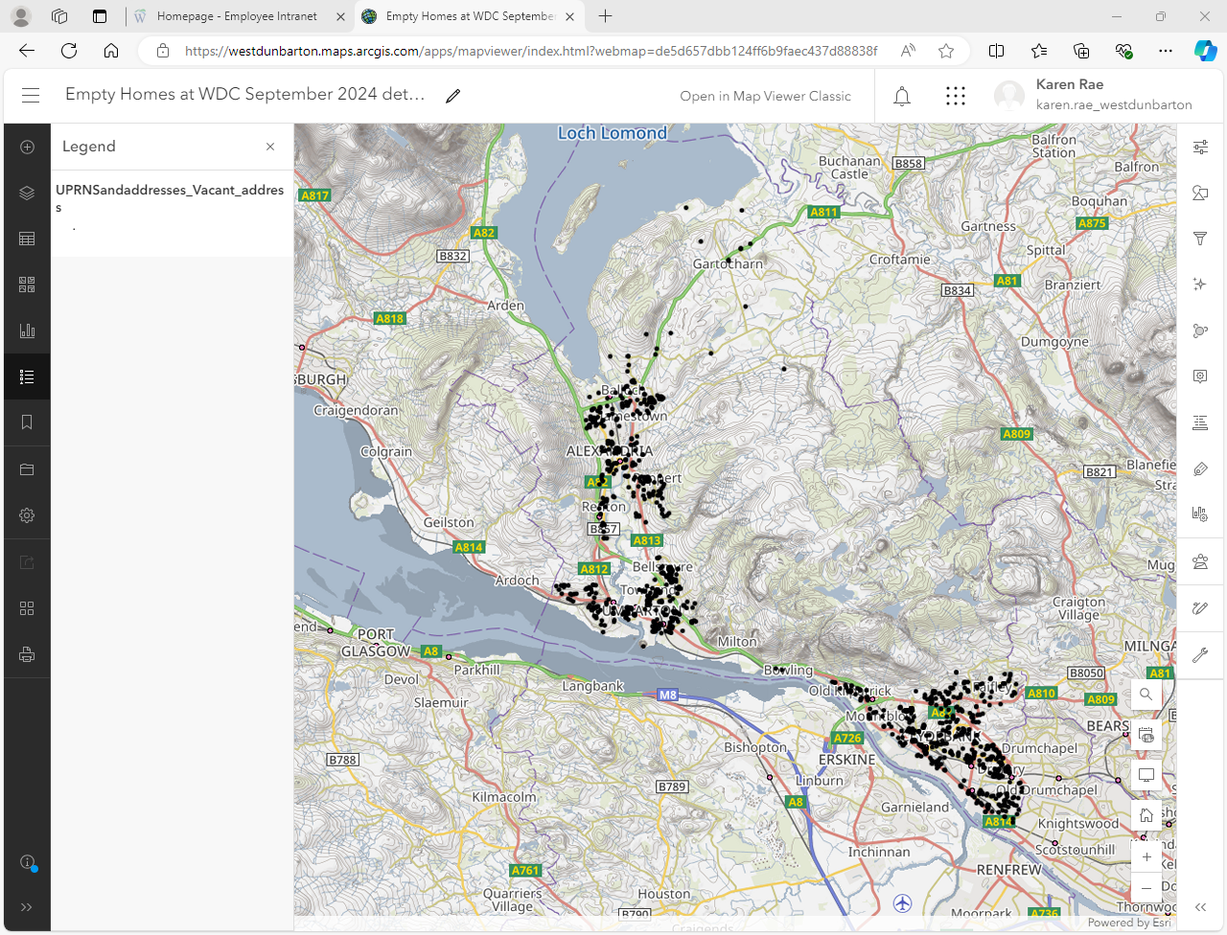

Table 5 details the breakdown of homes in each Council Tax Band in West Dunbartonshire Council with the highest levels of long-term empty homesand unoccupied exemptions**.** The table indicates that bands A and B in all areas of West Dunbartonshire have the highest amount of long-term empty properties and are therefore more likely to be flats, current and former Local Authority housing stock and/or Registered Social Landlord housing stock. Where there are mixed tenure blocks of flats it can be difficult for the Local Authority to get agreement from other owners to proceed with common works, and for the Authority to meet its obligations to meet the Scottish Housing Quality Standards in these mixed tenure blocks.

|  |  |  |  |  |  |  |  |  |  |
| --- | --- | --- | --- | --- | --- | --- | --- | --- | --- |
| Geography | Total dwellings | % Band A | % Band B | % Band C | % Band D | % Band E | % Band F | % Band G | % Band H |
| Alexandria | 257 | 2.8% | 11% | 3.2% | 2.4% | 1.8% | 0.3% | 0.1% | 0% |
| Clydebank | 545 | 16% | 19% | 4.3% | 3.6% | 2.0% | 0.8% | 0.3% | 0% |
| Dumbarton | 389 | 11.2% | 12.8% | 4.0% | 2.4% | 1.7% | 0.2% | 0.1% | 0.3% |
| **Total %** | 2.6% | 30% | 42.8% | 11.5% | 8.4% | 5.5% | 1.3% | 0.5% | 0.3% |

***Table 5: Number and % Empty Properties by Council Tax Band***

Table 6 breaks down all empty homes into the length of time they have been empty. From the table we can conclude that the majority of empty homes within West Dunbartonshire have been empty for under 3 years. The next category of empty homes are those empty between 5- 10 years. The longer a home is empty the harder it is to bring it back into use.

|  |  |  |  |  |  |  |  |  |
| --- | --- | --- | --- | --- | --- | --- | --- | --- |
|  | West Dunbartonshire | | Alexandria | | Clydebank | | Dumbarton | |
| **Length of time empty** | No. of Empty Homes | % of Empty Homes | No. of Empty Homes | % of Empty Homes | No. of Empty Homes | % of Empty Homes | No. of Empty Homes | % of Empty Homes |
| |  | | --- | | 6-12 months | | 187 | 15.7% | 64 | 5.4% | 60 | 5.0% | 64 | 5.4% |
| 1-2 Years | 180 | 15.1% | 17 | 1.4% | 84 | 7.1% | 79 | 6.6% |
| 2-3 Years | 139 | 11.7% | 79 | 6.6% | 47 | 4.0% | 13 | 1.1% |
| 3-4 Years | 15 | 1.3% | 5 | 0.4% | 7 | 0.6% | 3 | 0% |
| 4-5 Years | 10 | 0.8% | 2 | 0.2% | 5 | 0.4% | 3 | 0.3% |
| 5-10 Years | 65 | 5.5% | 21 | 1.8% | 35 | 2.9% | 9 | 0.8% |
| 10 Years + | 18 | 1.5% | 14 | 1.2% | 0 | 0% | 4 | 0.3% |

***Table 6: Empty Property Timescales***

While unoccupied exemptions include properties which are empty and unfurnished for less than 6 months, local authority dwellings awaiting demolition, and some other homes empty for less than six months; the term also covers privately owned properties that are empty due to the property being repossessed, the death of a previous owner, the owner being in long term care or detention, dwellings last occupied by charitable bodies, dwellings empty under statute and some other privately owned homes that have been empty for six months or longer.

Some of the reasons for properties being empty in West Dunbartonshire are detailed in table 7. The main reason for property being empty in West Dunbartonshire is due to deceased owners. These properties can be difficult to bring back into use particularly where the person has died intestate. The family can find the situation difficult to deal with due to emotional attachment, meaning they are often reluctant to address the empty home. In situations like this it can take a considerable amount of time and perseverance from the Empty Homes Officer to get the property brought back into use, if at all.

Another issue is where owners have been taken into care, leaving their home empty. In many cases the property will lie empty until either someone acting on the behalf of the owner is legally permitted to act on behalf of the owner and takes action to sell the home, or the owner dies.

If brought back to use, these properties may contribute towards delivery of national policy outcomes and LHS priorities. However, there is a high likelihood of them remaining empty without Empty Homes Officer intervention. Table 7 provides an indication of the number of unoccupied exemptions in West Dunbartonshirethat may fall into these categories.

|  |  |
| --- | --- |
| Property Description | No. Empty Properties |
|  |  |
| All unoccupied exemptions; of which |  |
| Deceased Owners | 271 |
| Under renovation | 3 |
| Held for minister | 5 |
| Provides/receives care | 58 |
| Repossession | 5 |
| Receiving empty home discount (over 6months empty) | 114 |
| Other | 11 |

***Table 7: Unoccupied Exemption Description***

## 3.3 Housing Need and Demand

Empty homes activity contributes to increasing housing supply to meet the demand for affordable and market housing in West Dunbartonshire. Bringing empty homes back to use can also support West Dunbartonshire to meet its statutory duty to the prevent homelessness wherever possible and to mitigate the impact of homelessness where it cannot be prevented and increase provision of specialist housing units across categories such as wheelchair, amenity and sheltered.

West Dunbartonshire Local Housing Strategy (2022-2027) forecasts the housing estimates for market and affordable housing, for the period 2012-2029. On average West Dunbartonshire needs a minimum of 80 new social homes per annum and 150 private homes per annum. Returning empty homes to use can help to relieve some of the housing pressures within the Council area. This is important when we consider that West Dunbartonshire declared a housing emergency in May 2024.

## 3.4 Homelessness

Tackling homelessness has been a focus of Scottish Government policy and the legal and regulatory framework which has been put in place means that Scotland has some of the strongest rights in the world for anyone experiencing homelessness.

Local authorities have a statutory duty:

* to provide advice and information about the prevention of homelessness
* to carry out a robust homelessness assessment within 28 days
* for the provision of suitable temporary accommodation for those who require it
* to secure the provision of permanent accommodation when assessed as homeless
* to assess support needs for those found to be “homeless or threatened with homelessness unintentionally” and who we have reason to believe requires a support assessment.

West Dunbartonshire declared a housing emergency in May 2024 due to the demand on its housing services and the increasing use of temporary accommodation resulting in breaches of the unsuitable accommodation order.

Table 8 provides a summary of the homeless applications received by West Dunbartonshire and Scotland as a whole.

|  |  |  |  |  |  |  |
| --- | --- | --- | --- | --- | --- | --- |
| Applications | **2018-19** | **2019-20** | **2020-21** | **2021-22** | **2022-23** | **2023-24** |
| West Dunbartonshire | 1037 | 1022 | 1053 | 1205 | 1217 | 1095 |
| Scotland | 36,778 | 37,053 | 34,345 | 35,759 | 39,006 | 40,685 |

***Table 8: Homeless Applications***

Table 9 provides us with the 5 main reasons for persons seeking assistance from the Homeless Team. The most common reason is for those being asked to leave their accommodation and often this can be attributed to a parent asking a young person to leave, an example of this could be the home is overcrowded, or their relationship has become untenable.

|  |  |  |  |  |  |  |
| --- | --- | --- | --- | --- | --- | --- |
| Main Reasons for Homeless Applications | **2018-19** | **2019-20** | **2020-21** | **2021-22** | **2022-23** | **2023-24** |
| Asked to leave | 264 | 263 | 291 | 383 | 419 | 367 |
| Dispute within household / relationship breakdown: non-violent | 185 | 153 | 245 | 229 | 228 | 229 |
| Dispute within household: violent or abusive | 169 | 215 | 233 | 245 | 212 | 187 |
| Other reason for leaving accommodation / household | 135 | 81 | 78 | 83 | 92 | 72 |
| Discharge from prison / hospital / care / other institution | 45 | 49 | 34 | 45 | 49 | 51 |

***Table 9: Main Reasons***

## 3.5 Temporary Accommodation

Table 10 provides us with the details of the demand for temporary accommodation. This shows an increase for temporary accommodation which affects the availability of housing stock. There has been an increase on the number of persons being placed in bed and breakfast accommodation breaching the Unsuitable Accommodation Order. This has been reported to the Scottish Housing Regulator.

|  |  |  |  |  |  |  |
| --- | --- | --- | --- | --- | --- | --- |
| Use of Temporary Accommodation | **2018-19** | **2019-20** | **2020-21** | **2021-22** | **2022-23** | **2023-24** |
| West Dunbartonshire | 988 | 1026 | 1070 | 1176 | 1173 | 1224 |

## ***Table 10: Use of temporary accommodation***

## 3.6 Private Rented Sector

West Dunbartonshire Council has a relatively small private rented sector accounting for around 6% of the housing stock. A Help to Rent scheme was introduced to help clients with an identified housing need, access the private rented sector by providing the initial deposit. The amount of the deposit payable is limited to the Local Housing Allowance rates for the relevant size of accommodation. Many private lets charge considerably more than the local housing allowance rates and this can be a barrier to clients on lower incomes accessing the private rented sector. However, not all clients require assistance with the deposit and the numbers below cover all clients housed in the private rented sector.

|  |  |  |  |  |  |  |  |
| --- | --- | --- | --- | --- | --- | --- | --- |
| Homeless Outcome | **2018-19** | **2019-20** | **2020-21** | **2021-22** | **2022-23** | | **2023-24** |
| Private Rented Tenancy | 10 | 20 | 26 | 18 | | 7 | 19 |

***Table 11: Private Rented Sector***

# 4. Local Action, Challenges & Barriers in Tackling Empty Homes

As well as evidencing the need to tackle empty homes in West Dunbartonshire the Empty Homes Strategy builds upon the activity and interventions which have succeeded in bringing empty homes back into use; as well as specific local challenges and barriers to tackling empty homes.

The Strategy therefore builds on successes that have been achieved by projects and initiatives within West Dunbartonshire as well as innovation in empty homes activity across Scotland, other parts of the UK and elsewhere as the basis of piloting or programming future activity.

## 4.1 Empty Homes Projects and Initiatives in West Dunbartonshire

West Dunbartonshire has incorporated the following initiatives to help bring empty properties back into use:-

**Buy Back Scheme** – this is where we can purchase former local authority housing stock, and we will also consider purchasing other stock that meets tenant demand for the style, type and location of the house. The Empty Homes Officer can identify long term empty homes that could be suitable as buy-backs.

**Matchmaker Scheme** – this is where owners can register their home for sale and we then try to match the property to prospective purchasers who have also registered for the scheme. Owners will receive the details of the interested parties and they can then decide who they wish to contact to arrange a viewing of the property. This allows the owner to remain in control of the discussions and sale of the empty home.

**Empty Home Loan** – this is a fund of £150,000 that West Dunbartonshire received from the Scottish Government. As the loan was unused a survey was issued to empty homeowners. The results of the survey indicated that the main reason for the loan being unused was that the criteria was too restrictive. A loan variation request has been sent to the Scottish Government and we await their response.

**Help to Rent Scheme** – this is where the Empty Homes Officer can provide assistance to clients interested in the private rented sector. It is another tool that can be used to encourage home owners to return their home to use.

**Town Centre Regeneration** – The Empty Homes Officer will be working closely with colleagues in the Regeneration Team to provide support to engage with empty homeowners for the purposes of improving the buildings in the Town Centre conservation area.

**Council Tax -** The Empty Homes Officer works closely with colleagues in Council Tax and Corporate Debt to ensure that any outstanding debt can be collected, where appropriate.

**Compulsory Purchase Orders** - The Scottish Government are keen for local authorities to use compulsory purchase orders to bring empty homes back into use. However, Compulsory Purchase Orders will be viewed as an option of last resort for properties that are structurally unsound, unsafe, or are otherwise putting communities at risk but we will always seek to work with owners and landlords before taking a CPO forward

**Compulsory Sale Orders** – the Scottish Empty Homes Partnership (SEHP) has been advocating for the Scottish Government to introduce Compulsory Sale Orders for some time. In the SEHP Annual Report 2023-2024 they continue to recommend the introduction of Compulsory Sale orders and Compulsory Rental Orders as tools to bring empty homes back into use. West Dunbartonshire Council will support this initiative if it becomes available.

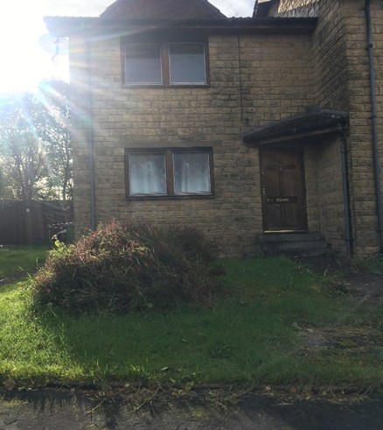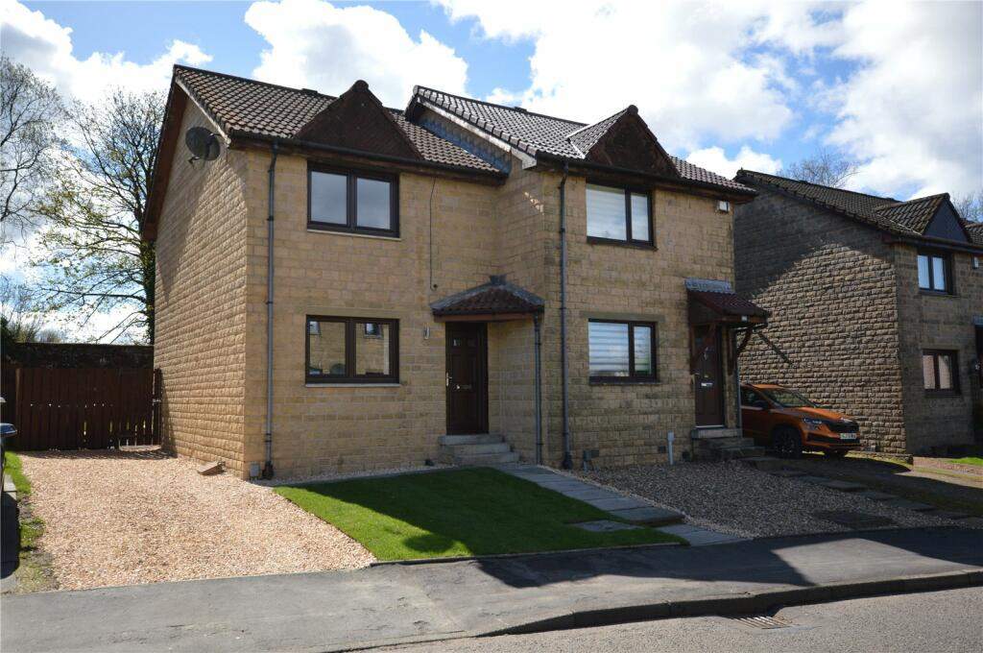**Case Study 1**

After Renovation

Before Renovation

This semi-detached property had been empty since 2015.

The owner had been admitted to hospital and while the house was empty there was a flood at the property causing extensive damage. The owner did not have the funds to repair the damage and was unable to occupy the property on their release from hospital and moved in with a friend.

The Empty Homes Officer (EHO) received complaints about vermin in the garden and the general condition of the garden and traced the owner’s whereabouts from Council Tax records. The owner engaged for a while and was keen to sell but then we had the arrival of the pandemic, lockdowns and contact was lost.

After several visits and correspondence issued, the owner finally engaged with the EHO late 2023. By this time the owner’s health had deteriorated and they informed the EHO that they were unable to get out and about. The owner agreed to allow their friend to act on their behalf. The friend and EHO visited the empty home and discussed the options available. The friend agreed the house would have to be sold as the owner did not have the funds available to get the house up to standard for them to live in, but they were not interested in selling at auction. Information about local estate agents was provided to the owner.

Soon after a further visit was made to discuss the owner’s decision. The owner confirmed that they had been in contact with a developer and had accepted an offer with the sale due to conclude in a matter of weeks.

The EHO kept in contact with both the owner and the developer during the house sale which concluded in January 2024. Information about VAT savings were shared with the developer.

The developer has since renovated the house to a high standard with the work completed in April. The house was quickly put back up for sale and sold at the closing date. The house will now be occupied for the first time in 9 years.

Before Renovations

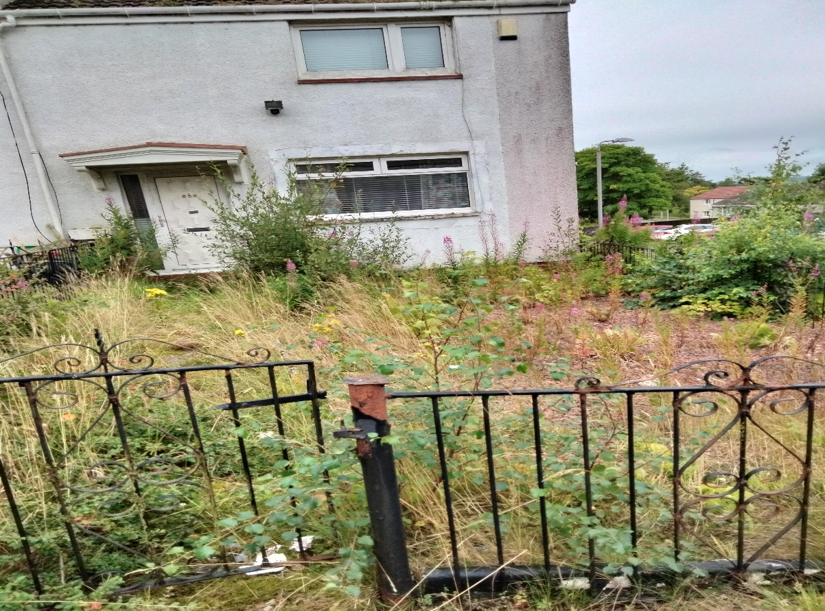

**Case Study 2**

This end terrace is a former West Dunbartonshire Council property and has been empty since 2014.

The owner had moved to receive care and then passed away. The Empty Homes Officer contacted the deceased owner’s legal representative who advised they were unable to take any action regarding the empty house as they required the court to appoint an executor; they also advised that this was a complicated estate. The legal representative advised that once an executor was appointed, they would then have to appoint genealogists. The Empty Homes Officer kept in contact with the legal representative for updates and they confirmed the intention was to sell the house, once the estate was approved by the court. The Empty Homes Officer shared information about the buyback scheme, and they confirmed the executor wanted to pursue this. The Empty Homes Officer liaised with the Buyback Lead Officer who confirmed that this house met the criteria for a buyback and would be considered for purchase.

The Empty Homes Officer met with the executor who confirmed their intention to proceed with the buyback scheme, however the court had still to legally appoint them as the executor. Due to further delays and complications the executor was not appointed until earlier 2024.

The house has now been purchased by West Dunbartonshire Council and is now being renovated, and once complete will provide social housing for someone with the relevant housing need.

## 4.2 Challenges and Barriers to Tackling Empty Homes

There are a number of key challenges and barriers to tackling empty homes in West Dunbartonshire which require to be proactively addressed by the development and delivery of this Empty Homes Strategy.

**Engagement.** It can be difficult for Empty Homes Officer to get engagement from the empty homeowner and for the empty homeowner to remain in contact with the Officer.

**Scale of Empty Homes**. Empty Homes are identified through council tax reports where a discount or exemption has been awarded to the council tax account either as a long-term empty home or an unoccupied dwelling. However, not all long-term empty homes are reported, and we plan to introduce an online reporting form where members of the public can easily access the form and provide details of the empty property.

**Tracing Owners**. Tracing owners can be particularly challenging. We have a service agreement with two genealogist companies who will try to trace owners on our behalf. There is no charge for this service. The Empty Homes Officer also has access to a system used by many British local authorities to try to trace owners.

**Relevant Information**. The Empty Homes Officer ensures that the suite of information leaflets available for empty homeowners are kept up-to-date. The leaflets range from information about supplier discounts to the possible VAT savings for works being carried out to empty homes, which can result in considerable savings for the homeowner.

**Vandalism and Antisocial Behaviour**. Empty homes are often a blight on the local community and can attract unwarranted attention causing the empty home to become a concern to those living within the neighbourhood of the empty home. The Empty Homes Officer will work closely with colleagues in the Antisocial Behaviour Team and Environmental Health where complaints of antisocial behaviour around empty homes have been identified.

**Common Repair Works**. An empty home can be located within a tenement flat or adjoined to other houses with a common interest i.e. chimneys, roofs. If the empty home is not being maintained the deterioration of the property can affect the adjoining properties. Homeowners may be unable to trace the absent owner to discuss the common works required. Disputes over common repairs are relatively common for empty properties.

**Financing Repairs**. Many empty homes require significant works to bring it up to the repairing standard and many owners do not have the financial resources to carry out the necessary works. With recent increases in the cost of both materials and labour following the pandemic, this can have a negative effect on the owner being able to afford the repairs.

These challenges have been identified through the development of the empty homes evidence base and by engaging with local partners and stakeholders involved in empty homes activity.

Some of the key local barriers to developing and implementing a strategic approach to empty homes includes:

* **Resources**: West Dunbartonshire Council received funding for an empty home loan fund but to date the loan has not been used. A survey was conducted, and it concluded that homeowners felt the loan was too restrictive. A loan variation has been sent to the Scottish Government and we await their decision.
* **Legal complexities**:- Challenging cases where owners can’t be traced, or ownership is in dispute can be extremely time consuming.
* **Legal or financial constraints** - West Dunbartonshire Council will consider using Compulsory Purchase Orders, but it will be viewed as an option of last resort for properties that are structurally unsound, unsafe, or are otherwise putting communities at risk but we will always seek to work with owners and landlords before taking a Compulsory Purchase Order forward.
* **Council Tax Increased Empty Home** **Levy** – West Dunbartonshire Council had a discretionary policy whereby owners could receive discretion from the increased levy for a set period of time. In December 2022 this policy ended. The ending of this policy may have prevented owners from completing work to bring the property up to habitable standard. Since April 2024 the Scottish Government has amended the Local Government Finance (Unoccupied properties etc. (Scotland) Act 2012, so all new owners no longer automatically have the increased council tax levy applied to the account, they are excluded from the increased levy for 6months.
* **Lack of awareness of empty homes work and the opportunities for advice and assistance**: - Greater marketing and communication to raise awareness and encourage engagement would be beneficial.
* **Shortage of tradespeople or materials**: - Homeowners who are engaging with the Empty Homes Officer have reported that they have to wait some time for tradespeople to be available, and that the costs for both labour and materials have increased significantly.

# 5. The Strategy for Tackling Empty Homes in West Dunbartonshire

This Empty Homes Strategy sets out how the Council and partners will work together over the next 5 years to proactively tackle the impact of empty homes on communities, neighbourhoods, homeowners and residents across West Dunbartonshire.

To achieve this, the following aim has been set for the Empty Homes Strategy:

• **To return 125 empty properties back into use over the term of the strategy**

This aim provides the overarching vision for empty homes in West Dunbartonshire. It sets out what the Council and partners want to achieve in tackling empty homes and reflects the level of ambition agreed with delivery partners. It also reflects the strategic aim of the Scottish Empty Homes Partnership to ‘bring as many privately-owned empty homes back into use as possible’. It will also reflect the ambitions of the Local Housing Strategy to provide safe and vibrant communities, 20 minute neighbourhoods as existing properties may already fall within this criteria, it may also help to provide specialist housing i.e. wheelchair accessible in areas where we do not have this type of accommodation.

The key issues identified to bring empty homes back into use are detailed below:

**Help alleviate the effects of homelessness and the waiting list within West Dunbartonshire**

West Dunbartonshire has declared a housing emergency due to the increase in housing demand and the lack of accommodation available. Homeless and waiting lists figures have been increasing and although there continues to be a new build programme, this is not the only option to reduce these numbers. Returning empty homes into use can be another tool to reduce these numbers.

**Support Town Centre Regeneration**

The Empty Homes Officer works closely with the Regeneration team to help locate absent owners. As the Council Tax Legislation prevents the sharing of information with the Regeneration Team, the Empty Homes Officer will work as an intermediary to trace these absent owners and attempt to engage with them. The Empty Homes Officer can also provide information to allow any necessary works to have reduce rated, and sometimes zero rated, VAT which will have a significant financial benefit for those undertaking significant works.

**Reduce the number of long-term empty problem properties**

The Empty Homes Officer receives reports from Council Tax bi-annually for all properties with an empty home exemption/discount and for those properties where the owner has died, repossessions, housing to be demolished etc. The purpose of these reports is to allow the Empty Homes Officer to contact the owner(s). Initially a letter and empty home survey will be issued and when returned this allows the Empty Homes Officer to tailor any support identified from the survey. Cases remain open until the house has been returned to use.

**Collaborate with the Buy Back Lead Officer to assist with bringing long term empty homes back into use**

The Local Housing Strategy aims to acquire housing that can increase the stock of WDC social housing and potentially assist with bringing empty homes back into use. By working with the Buy Back Lead Officer suitable long term empty homes can be identified and discussions can be had with the owners where appropriate.

# 6. Empty Homes Action Plan

The following Action Plan has been developed to enable the Council and partners to plan, deliver, monitor and evaluate the impact of empty homes activity over the next 5 years. It sets a framework for partnership working and investment that reflects strategic objectives and creates a route map for delivering the aim of the Empty Homes Strategy.

The Action Plan sets out a range of milestones detailing the activity associated with implementation. The Action Plan, activities and targets will be reviewed annually to ensure partners are able to respond flexibly to changes in need across West Dunbartonshire.

|  |  |
| --- | --- |
| Objective 1 Maximise the re-use of Empty Homes | Milestones |
| Action – to return 125 empty properties into use over the term of the strategy | * Maintain a private sector database of empty homes * Receive bi-annual reports from Council Tax * Work with Council Tax to ensure records are as accurate as possible * Engage with the Council’s media team to highlight empty homes and the support available * Ensure that the reporting of empty homes is easily accessible * Review standard letters |
| Objective 2 Help alleviate the effects of homelessness and the Milestones  Waiting list in West Dunbartonshire | |  |
| Action - Manage the Help to Rent Scheme for WDC | * Work with private landlords to encourage them to engage with the scheme * Report annually to the Housing and Communities Committee * Ensure appropriate staff are aware of the scheme and how to refer |
| Objective 3 Support Town Centre Regeneration Milestones | |  |
| Action - Engage with Planning and the Regeneration Team for town centre improvements | * Help to identify priority properties and assist with reaching out to absent and long-term empty home owners * Maximise grant funding for owners where available |
| Objective 4 Reduce the number of long term empty problem properties Milestones | |
| Action - Effective processes are in place to address properties that are in serious disrepair | * Identify the most appropriate course of action to address issues with the empty home and instigate enforcement action for those owners who fail to co-operate * Influence the development of the Local Housing Strategy with regard to the value in tackling empty homes in the private sector * manage the Empty Home Loan fund * Identify and pursue potential sources of funding to develop further empty homes incentive scheme including with external organisations’ and partners * Encourage owners to consider the matchmaker scheme to bring their home back into use * Work with colleagues in Building Standards, Planning, Environmental Health and Regeneration to address problem empty homes |
| Objective 5 Buy Backs Milestones | |
| Action - Collaborate with the Buy Back Lead Officer to assist with bringing long term empty homes back into use | * Promote the Buy Back scheme on the Empty Homes webpages * Work with the Buy Back Officer to identify relevant opportunities to purchase housing that meets the needs and demands of WDC |

# 7. Monitoring Progress and Evaluating

The actions scheduled under each strategic objective, have been developed into the detailed Action Plan along with milestones, in Chapter 6. It also sets out resources and partner responsibilities to guide implementation and delivery. This Action Plan provides a strong basis for monitoring progress in implementing the Empty Homes Strategy on a regular basis.

In order to monitor progress and achievements the following monitoring arrangements will be adopted:

* Number of empty homes returned to use each year of the strategy
* Annual updates of Action Plan where appropriate
* Number of buy backs returned to use each year.

## 7.1 Evaluation

It is important to ensure that the evaluation of the Empty Homes Strategy is reported to relevant partners and stakeholders as well as internally within the local authority. This evaluation reporting will include:

* demonstrating progress against actions that contribute to the LHS, RRTP, Community Plan and Corporate Plan
* the wider partnership frameworks which are achieving shared or national objectives.

This regular programme of evaluation with provide the Council and partners with an opportunity to understand:

* the progress that has been achieved
* current position
* delivery improvements required.

This approach will provide an assessment of the successes and challenges associated with tackling empty homes and provides a transparent approach to improvement planning and scrutiny.

# 8. Consultation & Engagement

Consultation has been central to the development of this strategy and views were sought from the West Dunbartonshire Tenants & Residents Organisiation( WDTRO), staff, other relevant departments and the Scottish Empty Homes Partnership. A formal consultation process for the draft strategy was carried out from 28th June 2024 to 30 September 2024 and the Empty Homes Strategy reflected the views of partners and stakeholders on the development of priorities and actions within the Strategy.

1. [https://www.gov.scot/binaries/content/documents/govscot/publications/strategy-plan/2023/02/national-planning-framework-4/documents/national-planning-framework-4-revised-draft/national-planning-framework-4-revised-draft/govscot%3Adocument/national-plannin](https://www.gov.scot/binaries/content/documents/govscot/publications/strategy-plan/2023/02/national-planning-framework-4/documents/national-planning-framework-4-revised-draft/national-planning-framework-4-revised-draft/govscot%3Adocument/national-planning-framework-4.pdf)
2. [Annual+Charts+and+Tables+2024.xlsx (live.com)](https://view.officeapps.live.com/op/view.aspx?src=https%3A%2F%2Fwww.gov.scot%2Fbinaries%2Fcontent%2Fdocuments%2Fgovscot%2Fpublications%2Fstatistics%2F2024%2F02%2Fhousing-statistics-2022--2023-key-trends-summary%2Fdocuments%2Fcharts-and-tables%2Fcharts-and-tables%2Fgovscot%253Adocument%2FAnnual%252BCharts%252Band%252BTables%252B2024.xlsx&wdOrigin=BROWSELINK)