Affordable Housing Design Standard
V.3 2023
Adopted 22 November 2023

Contents
Foreword from Councillor Gurpreet Singh Johal 3
Convener of Housing and Communities 3
Introduction: 4
Purpose: 5
Background: 5
Review Timeline: 6
How it works & what has changed 6
How the Design Standard works: 6
Affordable Housing Supply Programme Funding Requirements: 6
Design Standard 2020 v Proposed Design Standard 2023 7
Building design 8
Building Design: Buildings & Energy Efficiency 9
Building Design: Layout and design features 10
Building Design: Property Layout 11
Building Design: Bedrooms: 13
Building Design: Bathrooms: 13
Building Design: Kitchens: 14
Building Design: Stairs, Hallways, Storage & Circulation Space: 15
Minimum Space Standards 16
Minimum Space Standards: General needs 17
Minimum Space Standards: Wheelchair Accessible 18
Minimum bedroom sizes: General Needs/Wheelchair Accessible 20
Wheelchair accessible requirements 21
Wheelchair accessible requirements: Design considerations 22
Future-proofing 23
Future-proofing: Sustainability 24
Future-proofing: Internet ready 25
External areas: 26
External areas: Sustainability 27
External areas: Roads & Car Parking 28
External areas: Paths, Fencing & Cycles 29
External areas: Gardens 29
Dementia friendly design: 31
Dementia friendly design: General features: 32
Dementia friendly design: Lighting & External areas 33
Dementia friendly design: Kitchens 34
Dementia friendly design: Bathrooms 35
Glossary 36

Foreword from Councillor Gurpreet Singh Johal


Convener of Housing and Communities
I am pleased to present the revised and updated West Dunbartonshire Affordable Housing Design Standard 2023.
We first introduced our innovative Design Standard in 2015, setting the highest standards for new Council and Housing Association properties anywhere in Scotland. The Standard was updated in 2019 and this current revision improves further the quality of the new Affordable homes being built in West Dunbartonshire.
A number of other Local Authorities have followed our example, putting in place new build quality requirements that exceed those required by statute. We are committed to remain in the forefront of drive to provide the highest quality new affordable rented homes, ones which are equal to, or better than, those in the private sector in terms of space standards, accessibility and energy efficiency.
This revision stipulates a further step up in the energy efficiency specification of the new homes, with all new homes requiring being net zero or passivhaus, reducing both the carbon footprint and residents’ future heating bills. Good air quality within our homes is important for the health of tenants, and the new requirement to include an environmental sensor allowing temperature, humidity and CO² to be monitored.
West Dunbartonshire Council wishes to continue to assist in supporting the Scottish Government’s commitment to deliver new affordable homes in Scotland in support of the Housing to 2024’s vision for everyone to have a safe, good quality and affordable home that meets their needs in the place they want to be. The Housing to 2040 Strategy includes a target to provide 110,000 affordable homes by 2032. We continue to have an ambition to deliver as many as possible of these much-needed new homes, but do not wish to lose sight of quality in doing so.
The Scottish Government is currently consulting over its Housing for Varying Needs Standard that applies to new affordable homes in Scotland. A number of the proposals contained in the consultation mirror elements already in place in our Design Standard, suggesting that our direction of travel is the right one. The house-building environment is an ever-changing one, and this Design Standard will be regularly reviewed, learning from best practice to ensure that we are providing the very highest quality and sustainable homes for social housing tenants across West Dunbartonshire for current and future generations.
We welcome the support from the Scottish Government’s More Homes Division and our partner Housing Associations in delivering on this aim.

Introduction:

Purpose:
The purpose of the design standard is to ensure that the social homes being developed in West Dunbartonshire with the support of the Scottish Government’s Affordable Housing Supply Programme (AHSP) funding is of the highest quality and incorporates best practice design, enabling those who live in them to enjoy a high-quality home environment regardless of age, ability or health.

Background:
West Dunbartonshire Council has an ongoing ambitious programme of building new affordable social homes in partnership with housing association partners.
In April 2016, WDC introduced a design standard for housing supported by the ASHP, requiring new homes to meet higher standards in respect of floor space, accessibility and energy efficiency. The Standard applied to both Council and housing association new build homes. The last review of the Standard was carried out in 2019 resulting in the current version that applied to all new projects starting after April 2020.
While we have an ambition to deliver as many as possible of these much-needed new homes, we do not wish to lose sight of quality in doing so. When we first introduced our Standard, we carried out extensive research and consultations that demonstrated wide support for the measure. The Standard has helped to drive up the quality of the new social housing being developed across West Dunbartonshire, improving tenants’ homes now and for future generations.
Developers should take note of all current WDC Planning Guidance on Residential Development as contained in the Local Development Plan. In addition, prospective developers should be aware that National Planning Framework 4 (NPF4) is now in place and forms the most up to date part of our development plan. It will have precedence should there be any incompatibility between it and other parts of the development plan. This Design Standard complements the Planning Guidance.

Review Timeline:
- Summer 2023: Carry out a review of the Design Standard with consultation taking place with the Scottish Government, WD HSCP, RSLs and the WDTRO.
- Report proposed revised Design Standard to the November 2023 meeting of the WDC Housing and Communities Committee.
- Revised Standard to apply to all new schemes commencing after 1st April 2024.

How it works & what has changed

How the Design Standard works:
The Standard includes details of essential elements alongside a list of desirable elements that we are asking developers to consider. While some of these may be aspirational, we wish to encourage innovation and continuous improvement in housing design.
We recognise that whilst we are committed to building quality new affordable housing, a degree of discretion may be required where a project is finding it difficult to meet the full criteria due to particular characteristics of the scheme. Decisions on such matters will be the responsibility of the More Homes Board.

Affordable Housing Supply Programme Funding Requirements:
New Affordable Housing Investment Benchmarks introduced in June 2021 resulted in improved subsidy levels. The revised arrangements introduced a number of additional benchmark elements, a number of which are already contained within the Council’s Standard, that would unlock extra grant funding. A further update is due to be announced this summer.
These are:
- Silver Level Energy Efficiency Standard
- Provision of balconies in flats where outdoor space is limited
- Home working or study space (outwith that required of HfVN)
- Digitally enabling
- Ducting for electric vehicle charging points
- Installation of fire suppression systems
- Provision of zero emission heating systems.
See Scottish Government Guidance: https://www.gov.scot/publications/affordable-housing-supply-programme-process-and-procedures-mhdgn-2022-02/

Design Standard 2020 v Proposed Design Standard 2023
Key areas of the current Standard identified for possible development include:
- A better match of housing mix with identified housing need. In particular, we need to address the shortfall in larger family homes of four and over bedrooms and developers are encouraged to contribute on this issue.
- All new homes to be net-zero/zero-carbon or passivhaus standard. Currently, the Standard stipulates silver-plus level.
- We wish to look more closely at measures which can be taken to future proof our new homes for example on how best to enable the provision of bathroom/shower facilities to improve accessibility as the tenant’s needs change.
- There is an increasing awareness of the health harms that can be caused by dampness and condensation in homes. Environmental sensors have relatively recently been developed which can track temperature, humidity and CO² in the home. We propose to make these compulsory elements of new build projects.
The draft Design Standard contains a series of tables listing the essential and desirable elements proposed, grouped under the following headings:
- Building design: Buildings and Energy Efficiency
- Layout and design features
- Minimum space standards
- Disabled access requirements
- Future proofing
- External areas
- Dementia Friendly design.

Building design
Having well designed buildings is a basic requirement of our Design Standard. In addition to being well designed, homes should be sited to take advantage of, and mitigate, any weather conditions, for example taking into consideration sunlight and prevailing winds. We welcome innovative designs and solutions that make best use of their topography and location.
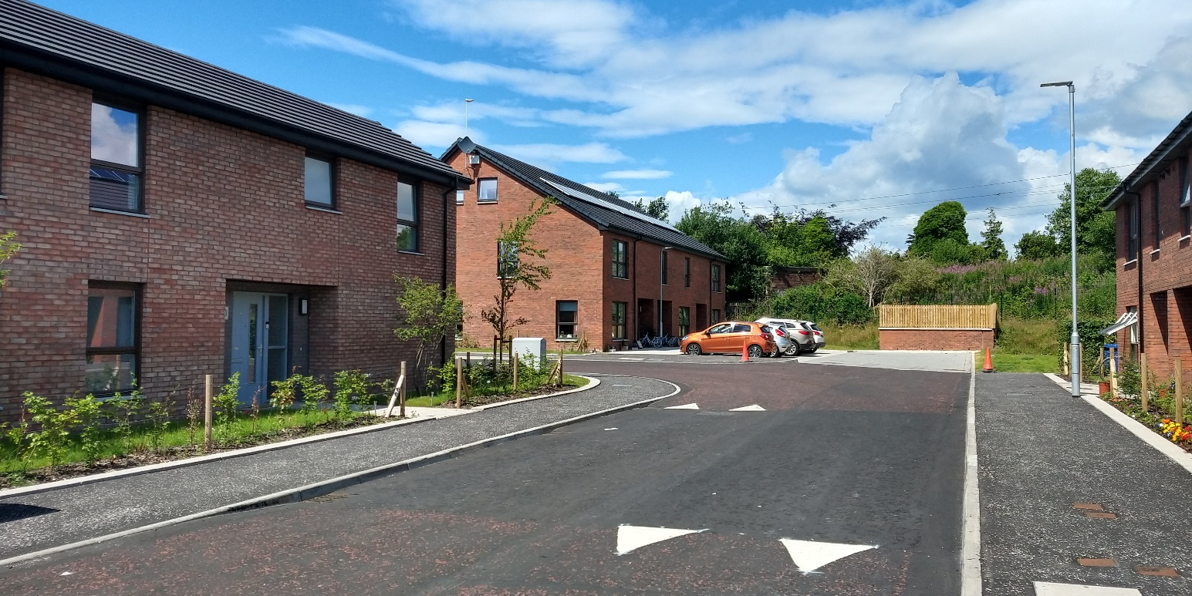

Building Design: Buildings & Energy Efficiency

Key to the tables:

E= essential (must be provided)
D= desirable (ideally should be provided
Element: | E: | D: | Comment:
Buildings designed to have a minimum life of at least 60 years. | X
All new homes must achieve an EPC rating of at least B. | X
All new homes must be net zero or Passivhaus i.e. meet at least  - Silver Active Level, Aspects 2-8  - Platinum Level, Aspect 1 | X |  | The Scottish Government is consulting over a national standard which we would expect to be of a similar high quality.
An environmental sensor must be installed in all new homes to monitor air quality. | X
Careful consideration should be given to providing the best orientation for the properties in terms of solar gain and potential cooling advantages |  | X
Main entrance doors should be positioned to take cognisance of prevailing winds |  | X
We encourage consideration of innovative carbon reduction measures, for example, Wastewater Heat Recovery systems (WWHRS), in new developments |  | X | Such measures may be required to meet energy efficiency but bring with them additional maintenance burdens.

Building Design: Layout and design features

The layout and design of a home are important features within a building and development design.
A well-designed space should not only give people the space they need to live comfortably, with enough storage space to accommodate their belongings but it should also offer flexibility in order to allow them to change how they use the space to suit their needs as they change.
This guidance applies to the overall layout but with specific guidance for bedrooms, bathrooms, kitchens and common spaces. It should be noted that many of these aspects are essential, rather than desirable.
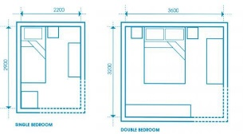
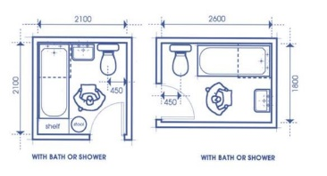

Building Design: Property Layout

Element: | E: | D: | Comment:
Dual aspect homes must be provided. | X |  | Only in very exceptional circumstances will dual aspect designs be acceptable, for example it may be unavoidable in some care projects serves by a corridor access. North facing single aspect properties will never be acceptable nor in homes with more than three bedrooms.
Level access must be provided to the principal entrances. | X |  | Where topography does not allow this, level access must be provided to another entrance, acceptable only in exceptional circumstances. Forthcoming revised
To meet HfVN, a home office space must be included in every property. | X |  | For dwellings over 150 m² floor area, two home office spaces must be provided.
All floor plans must show a furniture layout to comply with those set out in HfVN and should clearly indicate where the home office space is located. | X
Where a property does not have a garden area, we encourage the provision of a balcony. |  | X | Additional grant funding is available for provision of balconies in certain instances. “Juliet” balconies are unlikely to attract the additional grant.
The layout of adjacent dwellings, as well as lifts and circulation spaces, must seek to limit the transmission of noise to sound sensitive rooms | X
Internal ceiling heights must be a minimum of 2.4m in all habitable rooms, measured from finished floor level. | X

Building Design: Bedrooms:

Element: | E: | D: | Comment:
Double bedrooms must be capable of accommodating twin beds. | X
The bed space should be located such that the bedhead is not under the window. |  | X
Built-in wardrobes should be provided to all bedrooms, wardrobes should have sliding or slide hung finished flush doors, a continuous shelf and hanging rail. The internal depth of the wardrobe should not be less than 600mm. |  | X | See separate section on storage spaces for more detail. Only in exceptional circumstances may these be omitted.
Future provision for direct access from the main bedroom to a bathroom is desirable. |  | X

Building Design: Bathrooms:

Element: | E: | D: | Comment:
Internal bathrooms i.e. those without windows, should be avoided wherever possible |  | X
Baths should not be sited under windows |  | X
The preference is for the bathroom door to open outwards while ensuring this does not cause an obstruction in the hall. |  | X
Slip resistant floor finish (m R value = 11) and integrated coved skirting to be provided to all wet rooms; bathrooms, shower rooms and WCs. Coving in kitchens is preferred but optional. | X
A dwelling should have at least one accessible WC and wash hand basin and at least one accessible shower/ bath, located on the principle living level of a dwelling. |  | X

Building Design: Kitchens:

Element: | E: | D: | Comment:
Kitchen designs must include a dining space suitable for the size of the household. Only in exceptional circumstances should this be omitted. | X
Floor spaces within the kitchen (minimum 625mm clear width) must be allocated for a cooker, a full-height fridge/ freezer, and a washing machine. A dishwasher space is also encouraged. For dwellings for six people of more, a dishwasher space is required and space for a tumble drier with vent is encouraged. | X
Slip-resistant floor finish (min R value = 111_ and integrated coved skirting to be provided to all kitchens | X
Consideration to be given to providing floor finishes to open plan kitchen/ dining areas, especially where it is designed for a wheelchair user. |  | X
In eight-person and over homes, there should be a separate utility room with space for a sink and two appliances as a minimum. |  | X | Consideration should be given to providing a utility room in five person and over homes.

Building Design: Stairs, Hallways, Storage & Circulation Space:

Element: | E: | D: | Comment:
Tapered treads must be avoided in the design of stairs | X
Ceilings over stairs must be lower to match the rake of the stairs for ease of maintenance, while maintaining the required minimum 2000mm head- room. | X
Entrance doors to dwellings must have a minimum clear opening of 870mm | X
All external close entrance doors to be power assisted. | X
All corridors must have a minimum width of at least 1200mm (+ an increase at change of direction to allow a 1.5m turning circle). | X |  | New HfVN guidance is proposing the same.
Internal door widths must be a minimum 850mm clear width. | X
The maximum depth of a storage cupboard should be 1m. At least one cupboard should be free of hot water cylinders, boilers, heat exchangers, washing machines and the like and all part of the cupboard should be a minimum of 2000mm high. |  | X

Minimum Space Standards
Having the space you need and a home layout that allows you to live an active and comfortable life is our priority regardless of your age, ability or family structure.
Whilst existing homes may represent a challenge new build properties can aspire to deliver the best space standards and layouts and thus we have established minimum space standards to govern new developments.
These space standards include a guidance for the required standards for wheelchair users. In order to address the needs of wheelchair users within our communities as it stands at least 10% of properties in new developments must be entirely wheelchair friendly.
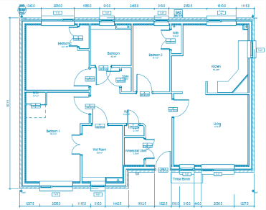

Minimum Space Standards: General needs

 | Minimum Net Floor Area
Number of bedrooms/ people | One-storey dwellings (m2) | Two-storey dwellings (m2) | Three- storey dwellings(m2)
1 bedroom  (1 person) | 33.0
1 bedroom  (2 person) | 50.5
3 person | 61 | 68
4 person | 73.5 | 79
5 person | 82.5 | 89.5 | 98.5
6 person | 90 | 97 | 102.5
7 person | 111.5 | 114.5 | 118.5
8 person | 120.5 | 123.5 | 127.5
9 person | 129 | 132 | 136

The above areas are based on the New Floor Areas, defined as:
- Living rooms, dining rooms, bedrooms, kitchens, bathrooms, shower rooms etc.
- General storage space including areas occupied by fitted cupboards
- Halls and staircases.
It excludes:
- Common Corridors, landing stairwells and areas of a shared nature
- Areas where the headroom is less than 1.5m
- Common utility rooms.

Minimum Space Standards: Wheelchair Accessible

 | Minimum Net Floor Area
Number of bedrooms/ people | One-storey dwellings (m2) | Two-storey dwellings (m2) | Three- storey dwellings(m2)
1 bedroom (1 person) | 43
1 bedroom (2 person) | 58.5
3 person | 75 | 82
4 person | 87.5 | 93
5 person | 100.5 | 107.5 | 116.5
6 person | 108 | 115 | 120.5
7 person | 122.5 | 136.5 | 140.5
8 person | 133 | 151 | 155
9 person | 147.5 | 161.5 | 165.5

The above areas are based on the New Floor Areas, defined as:
- Living rooms, dining rooms, bedrooms, kitchens, bathrooms, shower rooms etc.
- General storage space including areas occupied by fitted cupboards
- Halls and staircases
It excludes:
- Common Corridors, landing stairwells and areas of a shared nature
- Areas where the headroom is less than 1.5m
- Common utility rooms.

Minimum bedroom sizes: General Needs/Wheelchair Accessible

Element: | E: | D: | Comment:
Single bedrooms: the minimum floor area for a single bedroom, exclusive of built wardrobes, is 8m2 and must be a minimum of 2150mm wide.  Should have a wardrobe min 600mm by 800mm | X |  | General needs
Double bedrooms: the minimum floor area for a double/ twin bedroom, exclusive of built in wardrobes is 12.5m2.  One double or twin bedroom must be at least 2750mm wide and the others 2600mm wide.  Should have a wardrobe min 1200mm by 600mm. | X |  | General needs
The minimum floor area for a single bedroom is 10 m2 for wheelchair housing. | X |  | Wheelchair accessible
The minimum floor area for a double/twin bedroom is 15.5 m2 for wheelchair housing. | X |  | Wheelchair accessible

Wheelchair accessible requirements
Those who require the use of wheelchairs or have other challenges can potentially benefit the most from purposefully designed space.
It can allow them to comfortably enjoy their home, undertake activities with their friends and families which would otherwise have been challenging, and hopefully be independent and active within their communities.
Therefore, whilst we have provided space standards for wheelchair accessible homes, we have also in this section identified design features which should be incorporated in general homes where appropriate, in order to accommodate and future proof new developments for those with disabilities.
As noted in some tables in this document, the Housing for Varying Needs standard is currently under review by the Scottish Government and changes can be expected late 2025/26.
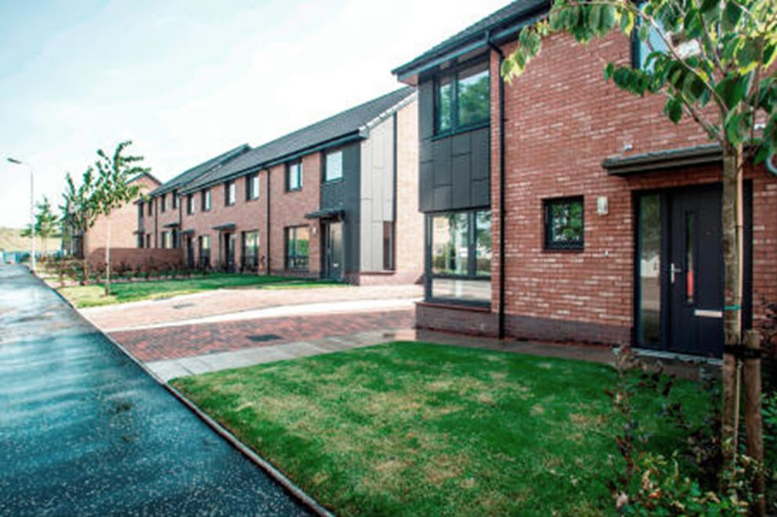

Wheelchair accessible requirements: Design considerations

Element: | E: | D: | Comment:
75% of G/F houses must be provided with a walk in shower unless there are especially difficult site constraints.  Where a bath is fitted in a G/F, a wet floor must be provided. | X
Consideration to be given to using contrasting colours and finishes around the doors to aid recognition for those with site impairment. |  | X | Something similar is likely to be introduced under the new HfVN.
For the benefit of people with sight impairment, floor surfaces must not be heavily patterned or of a gloss finish as this causes glare. | X
Door numbers and external door bells must be clearly visible against their background to assist people with a sight impairment. | X
Letter boxes should have cages to collect mail. |  | X
Where possible, all homes should have a G/F bedroom or future proofing option. |  | X | This is especially important for homes with 4 beds and more.

Future-proofing
West Dunbartonshire Council is committed to the development of homes that are not simply fit for purpose now but will continue to be high quality homes over the long term,
heated and powered from sustainable sources and incorporating technology for SMART homes.

Ensuring homes are future-proofed means investing in internet connectivity at the development stage and including home working from space appropriate for 21st century lifestyles.

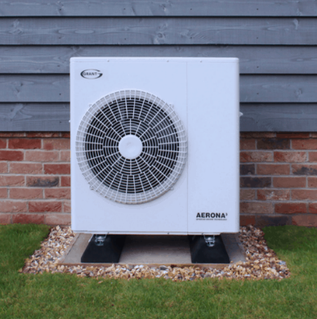

Future-proofing: Sustainability

Element: | E: | D: | Comment:
Measures that support the aim of decarbonising the grid, including provision of district heating systems (DHS), are encouraged. |  | X | Our Queens Quay DHS is being rolled out in Clydebank and we would welcome similar elsewhere.
LED lighting is preferred for communal  areas. |  | X
Consideration should be given to the inclusion of smart meters when second-generation models, are not tied to particular energy suppliers, when available. |  | X
Consideration should be given to incorporating mobile phone app based technology for managing home energy and security. |  | X

Future-proofing: Internet ready

Element: | E: | D: | Comment:
The Design Standard requires the provision of a home office space (see above and HfVN). | X
Provision of a communal satellite & Freeview television system must be specified for flatted properties in developments. Consideration should be made for additional points in the bedroom. A dual satellite dish such as Freebird should be considered, to allow wider access to international channels. | X
Provision must be allowed for ‘fibre to the premise’ so that any ISP can be utilised by the occupier | X
Inclusion of a cheap high speed fibre internet package through a particular provider should be considered. |  | X

External areas:
Creating Places details the Scottish Government’s vision to protect and enhance the built environment while their policy document Designing Streets promotes an approach to street design that challenges the primacy of motorised vehicles in neighbourhoods. Both our Local Development Plan (LDP) and Local Housing Strategy (LHS) put a strong emphasis on supporting these place-making principles and the ideas around 20-minute neighbourhoods.
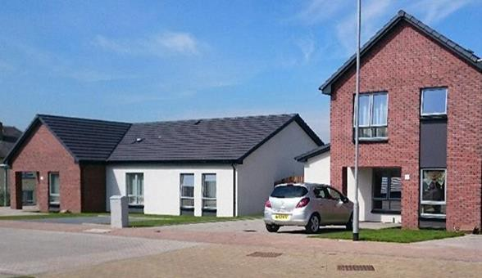
Developers should take note of all current WDC Planning Guidance on Residential Development as contained in the LDP. This Design Standard complements the Planning Guidance. The LDP will be subject to future amendment in view of the recently introduced National Planning Framework 4 (NPF4). NPF4 places an obligation on local authorities to meet the housing needs of people living in Scotland in particular older people and those with disabilities.

External areas: Sustainability

Element: | E: | D: | Comment:
Building Standards require the provision of an accessible space to allow for the safe, convenient and sustainable drying of washing (3.11.6). Drying space must be integrated into the design of external spaces. Such provision may be shared, provided the arrangement is practical. | X
Source Control Drainage shall be employed to minimise SuDS requirements and to provide a natural solution to rainwater runoff. This shall include maximising permeable elements in hard landscape areas subject to discussion with WDC Roads. | X
External lighting units will be subject to consultation with WDC Roads but must not distribute light above the horizontal plane. | X
Provision for Electric vehicles should be considered beyond the current technical standards - Section 7.2 June 2023 (charging points and ducting for future provision of the points). |  | X

External areas: Roads & Car Parking

Element: | E: | D: | Comment:
Developers should engage at an early stage with the Roads Authority to agree upon an environmentally sustainable solution which seeks to minimise car parking spaces. |  | X | We would encourage developers to minimise the provision of parking space, whilst meeting the requirements of WDC Roads Dept and having considered the nature of housing concerned.
Normally, Social Housing car parking should be provided at a level 1-step-down from PS mainstream developments: i.e. 1.5 spaces per dwelling with 3 or fewer bedrooms and 2 spaces per dwelling with 4 or more bedrooms. An acceptable design can include areas of landscaping showing a superimposed parking layout to the levels agreed with the Roads Authority, conforming to NRDG dimensions. | X
Areas of car parking should be designed to encourage other uses, such as play. A Designing Streets approach should be employed. |  | X

External areas: Paths, Fencing & Cycles

Element: | E: | D: | Comment:
Public footpaths and paths to houses must be a minimum 1200mm wide and should have a 1:100 cross fall. | X
Cycle parking should be provided for flatted developments at the rate of 1 space per dwelling, in line with Cycling By Design 2010. This should be located at ground level and be in a secure, covered environment (e.g. part of the building or a lockable compound) |  | X
Timber boundary fencing of gardens should not back directly onto public spaces, including paths. Consideration should be given to running a hedge/planting strip behind the boundary. |  | X

External areas: Gardens

Element: | E: | D: | Comment:
Planting where provided should include edible fruit species. |  | X
Front garden areas should contain hedges/taller shrubs to give a sense of privacy. Appropriate tree planting is also encouraged where space permits. |  | X
Where timber board fencing is used to define rear/side boundaries, self-clinging/ climbing plants or specimen shrubs should be used to break up the monotony. |  | X
A minimum useable garden space of 50m2 should be provided for each house. For flats, a minimum of 10m2 should be allowed per unit. |  | X | It is recognised that a balance requires to be struck between the amenity provided by the garden and the maintenance burden it may place on the tenant or housing developer.
Any areas of grass should be of a size, shape and accessibility which facilitate ease of maintenance. |  | X | Every effort should be made to avoid any “left-over space” which would present maintenance difficulties on completion of the homes.

Dementia friendly design:
Housing will play an increasingly important role in improving the conditions for people with dementia. WDC designates particular houses or projects as being “Dementia Friendly”. These houses employ a full range of assistive design measures, with the WD HSCP providing design advice. There is value in considering incorporating some of these elements as a matter course in mainstream housing as a future-proofing measure, particularly in ground floor properties.
The principles outlined in this section apply not only to those with dementia, but also to other people who would benefit from assistive measures including those with physical disability issues.
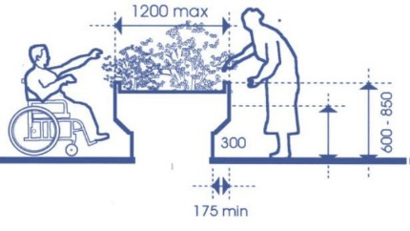

Dementia friendly design: General features:

Element: | E: | D: | Comment:
Flooring should be of a consistent tone |  | X
Noise pollution should be minimised  where possible |  | X | Even more important in Dementia Friendly homes.
Allow for easy installation of future telecare items |  | X
In appropriate locations, consideration to be given to wall/ceiling  structures capable of future installation of hoist and track systems |  | X
Care should be taken in selecting windows handles. Difficult to open handles or ones in contrasting colours may be appropriate |  | X
Two electric double sockets must be made available next to the telephone socket to allow for future telecare items | X
Spy holes should be provided to external doors (one at standing level, the other for wheelchair users) |  | X
Consideration to be given to provision of power switches which are in contrasting colours to the wall |  | X

Dementia friendly design: Lighting & External areas
Good lighting is particularly important for people with Dementia. Where possible, developers should seek to maximise lighting especially at key areas such as sinks, worktops, bathrooms and external pathways. Many of the design elements below apply equally to mainstream housing.
Element: | E: | D: | Comment:
Consider night time lighting pathways to bathrooms |  | X
Light switches should be in a contrasting colour |  | X
For some client groups dimmer lights in living room and bedrooms are beneficial |  | X
Element: | E: | D: | Comment:
Non-slip paving must be employed | X
Pathways must be well lit | X
Extra care should be taken creating short and clear access routes to bin stores and drying areas |  | X
Consideration should be given to providing raised planters in gardens |  | X
Planting of scented varieties is encouraged, especially near paths and doorways |  | X

Dementia friendly design: Kitchens

Element: | E: | D: | Comment:
There should be a continuous worktop between oven and sink |  | X
Good lighting is particularly important in kitchens at worktops and sinks and pelmet style lighting is encouraged |  | X
At least some cupboards should have glazed doors(or shatterproof clear material) |  | X
Cupboard door handles should be of contrasting colours |  | X
Taps should be lever, not mixer, and  marked “H” and “C” in red and blue |  | X
Worktops should be of a solid colour, not patterned, and should be of a matte finish |  | X
Sinks should be of generous dimensions |  | X
Install non-slip flooring | X

Dementia friendly design: Bathrooms

Element: | E: | D: | Comment:
Taps should be lever, not mixer, and marked “H” and “C” in red and blue |  | X
WC should have traditional handle flush levers or raised buttons |  | X
Consideration to be given to painting bathroom doors in strong contrasting colour |  | X
Provide large wash hand basins | X
Install non-slip flooring | X
Glare from tiles/wet boards should be minimised. Use a matte finish. |  | X
In wet rooms, which will have coved skirting, a contrasting capping strip should be included to make it clear where the floor ends and the wall begins. |  | X
Showers should have an automatic timed switch off/maximum temperature control |  | X

Glossary

Term | Description
Affordable Housing Supply Programme (AHSP) | The principal Scottish Government grant funding for Council and housing association new build.
Dementia Friendly Design | Design features which can support those affected by the condition to live longer independently.
Dual Aspect | A property with windows on two or more walls.
Energy Efficiency Standard for Social  Housing 1 & 2 (EESSH) | Measures introduced by the Scottish Government to improve energy efficiency and reduce fuel poverty. The standard sets out milestones for social landlords to reach by set dates.
Fuel Poverty | A household is deemed to be in fuel poverty if more than 10% of its income is spent on fuel use.
Housing for Varying Needs (HfVN) | Housing for Varying Needs: a design standard that requires new dwellings to be designed to be barrier free internally to ensure that a wide range of needs can be met. All homes funded through the AHSP must at least meet this standard. The standard is currently under review.
Local Development Plan (LDP) | The Local Development Plan: the statutory land use planning framework for West Dunbartonshire. The plan covers the whole of West Dunbartonshire with the exception of the area within the Loch Lomond and the Trossachs National Park. The current plan is the Proposed Local Development Plan 2, agreed for adoption by Planning Committee on the 19 August 2020. It covers the period to 2030.
Local Housing Strategy (LHS) | The Local Housing Strategy: the statutory document setting out the strategic housing priorities over a rolling 5-year period. The current version is the More Homes Better Homes West Dunbartonshire Local Housing Strategy 2022 – 2027.
National Roads Development Guide  (NRDG) | The National Roads Development Guide is Scotland’s principal guidance on roads, produced by the Society for Chief Officers of Transport in Scotland.
Place and Design Panel | A forum convened by West Dunbartonshire Planning that works collaboratively with developers, architects and the likes to provide advice and assistance in pre-application proposals to help ensure projects contribute to a culture of design excellence.
Standard Assessment Procedure (SAP) | Standard Assessment Procedure: a government energy rating for homes.
Strategic Housing Investment Plan (SHIP) | Strategic Housing Investment Plan: the annual document that sets out the funding priorities for affordable housing in West Dunbartonshire for the next five years and published every November.
Silver Standard | A sustainability level detailed in the Scottish Government’s  Building Standards Part  1: Technical Handbook – Domestic (Part 7.1 Statement of Sustainability). Sometimes referred to as Greener standard.
Silver Active Level | The sustainability level above Silver, which requires the inclusion of use of a low and zero carbon generating technology (LZCGT), usually meaning the inclusion of wind turbines, photo voltaic cells, combined heat and power units (fired by low emission sources) or some such items.
Sustainable Drainage System (SuDS) | A Sustainable Drainage System manages the impact of new developments on surface water drainage discharges. It may involve elements such as water retention basins and permeable surfaces.
Telecare | The range of equipment and services available to assist a person to remain safely in their own home. It includes things like movement and fall detectors, panic buttons and automatic medication management.
Waste Water Heat Recovery Systems  (WWHRS) | Waste Water Heat Recovery Systems are energy saving devices that recover heat/energy from waste water and use it for other purposes.
West Dunbartonshire Health and Social Care Partnership (HSCP) | The health and social care integration body with delegated authority from the NHS Greater Glasgow Health and West Dunbartonshire Council.
Wheelchair Accessible Standard | An accessibility standard requiring more than HfVN. These are homes with significantly increased floor areas.  Elements might include, for example, particular features in kitchens and bathrooms, hoist systems linking bedrooms to bathrooms and storage space for 2 wheelchairs. As defined under Housing for Varying Needs Part 1 - wheelchair standard.

If you have any questions or require clarification, please contact:
Jamie Dockery
Senior Housing Development Officer
Jamie.dockery@west-dunbarton.gov.uk

